Submission to: | The Productivity Commission
Title: | Business Regulation Benchmarking: Role of Local Government as Regulator
Date: | 21 October 2011

Contents

1. Introduction 3
2. The Australian Trucking Association 3
3. Overview 3
4. Recommendations 4
5. Cost inducing regulations and procedures of local governments 5
5.1. Higher mass limits and allowing access 5
5.2. Performance Based Standards 6
5.3. Local government planning 6
5.4. Case Study: audit report on the management of the Strategic Regional Program. 7
5.5. Result of excessive regulation 8
6. What industry needs 8
7. Conclusion 10
APPENDIX A: The ATA and Barkwood Consulting Pty Ltd Truck Impact Chart 11

Introduction

The Productivity Commission is intending to identify regulatory activities which cause unnecessary costs for businesses. In Australia, the political separation of powers means that regulations can vary significantly from different local governments. This has the potential to impose excessive costs and requirements on businesses.

Local governments are a variation of the states and territories and are therefore limited in their powers by state and territory laws. The Commonwealth provides grants for infrastructure and other services; however, local government accountability to the Commonwealth for this spending is limited.

Having policy which is consistent throughout Australia can lead to the removal of the inefficiencies that disconnected regulation and enforcement cause in the economy.

The Australian Trucking Association

The Australian Trucking Association (ATA) is the peak body that represents the trucking industry. Its members include the state and sector based trucking associations, some of the nation’s largest transport companies, and businesses with leading expertise in truck technology.

Overview

The heavy vehicle industry experiences regulation and compliance on a daily basis. As Australia is vast with many hubs of commerce far apart, it is necessary for the industry to operate in different local government jurisdictions. The heavy vehicle which is the industry’s work horse is the B-double. This vehicle allows for improved productivity due its size compared to a semi trailer. It also provides improved safety due to increased stability because of the way trailers are combined, and has been the main contributor to industry’s productivity gains over the past 20 years. Below we have provided a comparison of the heavy vehicles so the Productivity Commission can see why the industry and government entities, like Infrastructure Australia, want to encourage access to these high productivity vehicles.

Heavy vehicle | No. of trips per 1000 tonnes | Equivalent Standard Axle per 1000 tonnes (ESA)
Traditional 3 axle rigid | 77 | 316
Traditional 6 axle semi-trailer | 42 | 257
Innovative 9 axle B-double | 26 | 195
Innovative 12 axle B-triple | 20 | 178
Traditional 16 axle Road train | 15 | 197

Source: The ATA and Barkwood Consulting Pty Ltd Truck Impact Chart

What can be seen from the table is the more productive vehicles (B-doubles and B-triples) take fewer trips to complete a freight task of moving 1000 tonnes and impact to infrastructure (ESA) is reduced over traditional vehicles.

The main concern the heavy vehicle industry has is that access for these higher productivity vehicles needs to happen more readily. Local governments are coming under increasing pressure to allow high productivity vehicles on their roads in the face of safety, productivity and economic gains.

While access restrictions cause the industry to lose productive potential, when access is granted there are cases where excessive and unnecessary costs are forced onto operators in order to access local government jurisdiction routes. For instance, the use of permits for carrying dangerous goods vary in cost and the number needed in some local governments. This means operators capable of carrying dangerous goods are priced out of the market or simply find the system too complex to make sure all requirements are met.

Any business which uses road freight to move goods is affected by local government decisions. The costs or burden incurred by poor local government decision making which seeks to limit the movements of these productive heavy vehicles affects the productivity, price and future of businesses which need to access these vehicles. There is no doubt local government agencies with good access for high productivity vehicle prosper.

While the economic reasoning for allowing B-doubles and B-triples onto satisfactory local government roads is sound, the reality of the situation is many local governments simply do not want large heavy vehicles operating in their jurisdiction because of perceived community concerns. There is a tendency for local government to use the excuse they are protecting assets instead of investing in improvements which would allow for more productive trucks to operate. There is a misconception about the impact of heavy vehicles and people are generally unaware larger, heavy vehicles are safer, more productive and mean reduced truck numbers on the road.

This misunderstanding about heavy vehicles has a cost, which falls on operators, businesses who use road freight and those who consume the goods transported. The larger concern for local governments should be if they continue to block measures to allow productive heavy vehicles, they are damaging the business possibilities and future of their own communities.

The industry is like any other competitive entity; it is driven by competition, small profit margins and operating efficiently and as such, is sensitive to changes in costs. Recently the increase in registration charges on A-trailers, by around $5,000 a trailer, (which are part of B-doubles, B-triples and BAB-quads) has affected the industry by causing operators to move away from the most productive vehicles at an alarming rate. It cannot be underestimated how responsive the industry is to cash flow and costs.

Recommendations
Recommendation 1
Decisions made by local governments should seek to improve the productive potential of businesses with limited costs. Allowing access for high productive vehicles would increase the capability of business and communities, and therefore their economic well being.
Recommendation 2
Local governments should engage in nationwide programs in order to make for a seamless national economy. The viability of PBS is in question because of the failure of all local governments to provide the required maps to operators.
Recommendation 3
Local governments should seek to improve road planning and access procedures and best practices through utilisation consistent guidelines, employing skilled engineers and allowing externally reviewable access decisions.
Recommendation 4
Local governments should be held to greater scrutiny over how they allocate Commonwealth funds, in conjunction with increased audits to make sure accountability is achieved.
Recommendation 5
The ATA recommends the Productivity Commission use the heavy vehicle industry as a strong indication of where regulatory overlaps and distortions can lead to negative outcomes on businesses and communities.
Recommendation 6
Access decisions should be reviewable by an independent external tribunal if concerns are raised over the outcome that decisions have on businesses seeking access.
Recommendation 7
Regulation through Australia should be set to a uniform best practice level which makes interpretation easy and does not impose huge costs on operators.
Recommendation 8
Local governments should seek more interaction with constituents and businesses in order to address the market failure that currently occurs.

Cost inducing regulations and procedures of local governments

Local governments have a mandate to control road provision and maintenance. The bureaucratic system can and does, impose impediments onto businesses which want to use high productivity vehicles. The hindrance comes from restrictions placed by local government planning procedures and decisions.

  - Higher mass limits and allowing access

The main problem which causes productivity restrictions and costs on the industry is the lack of access for productive vehicles, and for vehicles which can carry higher mass limits. Allowing these vehicles to access routes means the freight movements could be undertaken more safely, with less road wear and at a cheaper cost for the operator and subsequently businesses.

While higher mass limits on road friendly suspension (RFS) for articulated vehicles were endorsed by the Australian Council of Transport in 2000, many local governments have still not agreed to sign up to this productive understanding which reduces the number of trips needed to move freight and allows additional mass for the same amount of road impact. Much of the rejection of RFS is due to misconceptions about the impact of high productivity vehicles.

In two states many of the routes which allow for access also come with other expensive obligations which cause another barrier to the viability of using higher mass limits. The Intelligence Access Program (IAP) involves government monitored GPS devices which track the movement of heavy vehicles. This is an expensive scheme which is said to be voluntarily, but if operators want to access areas where IAP has been specified you must have IAP fitted to your vehicles. IAP has been inappropriately applied to low risk situations, building significant industry objection. Generally, the industry has rejected IAP as a costly impost that is of limited value. Take up rates are very low.

Along with restrictions on higher mass limits operators find ‘first and last mile’ access problems also impose additional costs on businesses. Often larger heavy vehicle combinations have to de-couple in order to pass into local government areas in order to reach a destination, or when coming away from an origin. First and last mile constraints interfere with the freight task, as it can mean operators have no option but to use less productive heavy vehicle combinations for the whole journey. In other cases time and money are wasted while operators have to de-couple at designated depots in order to meet the requirements set by local governments.

It makes sense that road trains and other high productivity vehicles should not use quiet urban streets. B-doubles should be allowed to access many local government roads to access pick up and drop off points, as they are safe and handle well on the road. Last mile permits have been abused by local governments to prevent access to larger heavy vehicles full stop. Allowing access for high productivity vehicles to operate on these roads would complete the supply chain for operators, improve safety for the community and reduce road wear.

For the industry, limiting access is the biggest restriction that is holding back the productive potential of the Australian economy. If local governments do not want to see prices rise at their local stores, access for these high productivity vehicles must be reviewed.

Decisions made by local governments should seek to improve the productive potential of businesses with limited costs. Allowing access for high productive vehicles would increase the capability of business and communities, and therefore their economic well being.

  - Performance Based Standards

The Performance Based Standards (PBS) system was created to allow innovative vehicles that may comply with Australian design rules to meet select standards to prove their safety so they can operate as normal heavy vehicles. The rationale for the scheme is to make it easier for businesses to use innovative or specialised heavy vehicles. While businesses have complied with the strict criteria set, local governments and state agencies have made the scheme ineffectual, as PBS maps were supposed to have been produced in order to identify important information such as bridge capacity and rest stops for drivers. Local governments are either not able to indentify the routes for PBS maps because of lack of resources, or are not organised enough to do so.

PBS shows local governments are not providing services that businesses have paid for. This failing is huge. The scheme has been operational since 2007 and 80 trucks and buses have registered as PBS as of January 2010; and PBS mapping is still not complete. The scheme’s success would be greater if local governments were able to fulfil their role. The example of PBS shows if local governments do not adhere to the rules, the intent of productivity improving schemes is undermined considerably.

Local governments should engage in nationwide programs in order to make for a seamless national economy. The viability of PBS is in question because of the failure of all local governments to provide the required maps to operators.

  - Local government planning

Local governments, in many cases, lack the resources or training to make informed decisions on how road provision and maintenance projects should occur. Improving best practices and setting guidelines for approval and processes of road provision should be encouraged by the Commonwealth and the states.

Many businesses in rural areas struggle with gaining approval for planning heavy vehicle access to their premises. With rural companies, for growth in output to be accommodated they need to have this met with the use of larger heavy vehicles. Companies can apply for planning approval and road upgrading. In some cases a local government may quote a contribution for upgrading. However, there can be significant differences in the costs of road provision and in many cases companies seek private provision quotes and find them to be more cost effective. If local governments are to act more competitively, they should provide services at a competitive market level.

Planning failures may happen because many local governments don’t have the expertise in road management. This has been noted by Infrastructure Australia who have offered training programs for road providers in order to promote best practice of planning protocol and outcomes.

Planning procedures or access decisions that stunt the capability of businesses should be independently externally reviewable and this currently does not happen for access decisions. This discipline has been established in the Commonwealth; however, there is not the same requirement for road agencies and local government agencies. Verdicts of administrative review of decisions should be made public to agencies on a national level so consistency in policy is made.

Local governments should seek to improve road planning and access procedures and best practices through utilisation consistent guidelines, employing skilled engineers and allowing externally reviewable access decisions.

Local governments should be held to greater scrutiny over how they allocate Commonwealth funds, in conjunction with increased audits to make sure accountability is achieved.

  - Case Study: audit report on the management of the Strategic Regional Program.

The Australian National Audit Office (ANAO) carried out a performance audit on the Strategic Regional Program in the Department of Infrastructure, Transport, Regional Development and Local Government. The audit found that accountability over how Commonwealth funds were allocated and spent, and general practice of local government road provision was not working as efficiently as it should.

The Program stated projects were based on the merits of meeting a set of guidelines which were meant to promote regional Australian endeavours. However, failings in the drafting of these legislative guidelines did not enforce accountability on providers. Guidelines were updated in July 2009 aiming to improve the transparency and accountability of grants decision making processes. Nevertheless, the department found that by April 2010, 11 projects provided by local governments did not come under the requirements of the new grant guidelines.

Flaws in judgement were discovered, with problems in decision makers rating projects correctly and being able to rank and price up projects accordingly. Ministers were given projects that were rated low in eligibility that were still approved by the minister at the time. At the ANAO’s request ministers provided the evidence of projects that were not funded in 2006, they found that 83% of all application were not approved for funding.

The audit found that in 2006 “65% of projects approved for funding…by the then minister had either not been assessed against the published program guidelines; had been assessed as being ineligible under the guidelines; or had not been assessed as meeting the relevant criteria to a high degree.” Along with ministers approving projects which were rated with low eligibility, administrative best practice was not enforced with much of the paperwork not provided for projects that were approved.

The ANAO suggests a number of recommendations, based on its findings. Calling for enhanced financial management framework to improve the transparency and accountability of the decision making processes.
Improving cost versus benefit analysis for ministers, so that better judgement calls can be made. Approving projects based on how well they fit legislative guidelines and to promote value for money in for the commonwealth and constituents.

This case study and other ANAO audits support the view there needs to be increased accountability of decisions by local governments. The ANAO audits also show the need to improve the training resources that local governments currently have and better trained decision makers could lead to superior outcomes.

  - Result of excessive regulation

The difference in jurisdictional regulations and practice mean the fleet is not able to work at the optimal level for the economy. The industry faces two choices with differences in regulation. It can either lead to operators spending money on sufficient regulatory measures or it can mean operators met the minimum regulation required in jurisdictions. Both of these are not the general equilibrium which should occur. A market failure is present because of the disconnect in regulation.

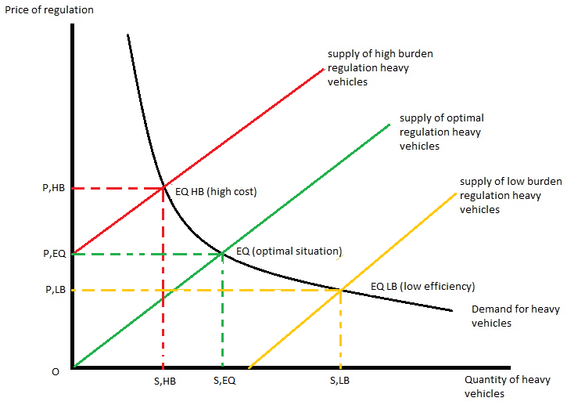

From the graph the effect of the cost of regulation on the industry is obvious. The equilibrium where supply and demand for heavy vehicles is optimum is where regulation costs set by local government and operators using the correct combination of heavy vehicles should meet (EQ,SEQ,PEQ). However, we have two divergences from the optimum combination of supply and demand.

Firstly, we have operators who want to use higher mass limits, and longer more productive vehicles, but in order to reach the regulation required to access this the costs associated with this regulation are high (P,HB). This causes the supply of these higher productive vehicles to be restricted (S,HB). This means fewer operators are using these vehicles than would like to. On the other hand we have an oversupply of vehicles that meet the basic regulation. The cost of meeting the regulation needed is a lower cost (P,LB rather than P,HB) and the equilibrium price (EQ LB). This means operators are using more of these lower hurdle regulation heavy vehicles such as semi-trailers instead of the higher hurdle regulated more productive trucks.

So the fleet receives the wrong signals because regulation is either incorrectly aimed, excessively costly or adapted to suit a specific council’s wishes, regardless of the economic drawbacks of those decisions.

The ATA recommends the Productivity Commission use the heavy vehicle industry as a strong indication of where regulatory overlaps and distortions can lead to negative outcomes on businesses and communities.

What industry needs

From the perspective of industry there are three reforms which could easily make the heavy vehicle industry as productive as it could possibly be.

- Process of review of decisions

Currently, decisions regarding road access for heavy vehicles are not reviewable externally. Local government agencies are not held to account for verdicts and do not have to justify their decisions. Over time, a series of tribunal decisions would establish precedents for local governments to use to make consistent decisions

Wrong decisions impose costs not just onto the companies seeking administrative review, but also onto government who have to engage in this lengthy and expensive process. Therefore, using external review of decisions may add more thorough thought on decisions and move agencies toward best practice decision making.

Ultimately, local government like any other government entity should be there to enable constituents, not impose costs which limit the legitimate business practices of companies. Tribunals would give a level of accountability which is desperately lacking currently.

- Standardisation

Having uniform charges and regulations across Australia would make road freight transport far more productive. It should be noted productivity gains in the last 20 years have come largely from the industry’s uptake of B-doubles. At the same time government regulation has not matched demand for B-doubles and the abilities they possess. Therefore, if Australia wants to achieve efficiency then it is imperative a uniform standard of local government practice is drawn up.

The National Heavy Vehicle Regulator is set to be a single regulator which will replace the numerous state agency roles that currently exist in this area. The industry hopes it will offer policies and regulations which apply nation-wide in order for operators to work with limited impediments. Local governments agreeing to national guidelines are key to the success of the whole project and the future of a productive and safe heavy vehicle industry.

Industry has had some involvement in the consultations with the NHVR, but there are fears industry could be left with unmet expectations. This exposes concerns of the model chosen to implement the NHVR concept will never be able to enforce uniformity with best practice regulation as states and local government will fight hard for their parochial approaches to regulation. For example, agencies are arguing the national law should not provide for the external review of decisions.

- Lack of industry interaction

Improvements can be made by bridging the gap between local governments and industry so more informed outcomes can be reached. Information sharing would improve the system without huge sums of money being spent or implementing major governance restructures. In reality, many of the concerns local governments have such as access to funds could be supported strongly if industry involvement was encouraged, leading to better outcomes for local governments and operators.

The issue of funding for roads and maintenance is going to become greater as the freight task increases. Local governments have struggled to access higher funds. The Australian Local Government Association has reported that over the past years the movement of grain from rail to road has and is going to have significant funding issues that need to be addressed. The industry agrees that local governments should receive their fair share of the monies which industry pays for its impact on the road network.

Engineering foundations for decisions in local government can differ considerably from the industry engineers; this problem could be resolved with better interaction. The road freight industry is also encountering negative attitudes of local governments and their desire for rail to be used more for freight. While road and rail are complementary, there are signs that rail is less attractive even though access prices are lower than road freight access prices. Presently on one NSW grain line network the cost recovery for government investment ranges from 0.86-6.3% with an average recovery of just 3%. While money is invested in rail, it fails to solve the issue of increased road freight in jurisdictions. Industry interaction between rail, road and local government would have a more freight task orientated outcome versus the current failings.

Access decisions should be reviewable by an independent external tribunal if concerns are raised over the outcome that decisions have on businesses seeking access.

Regulation through Australia should be set to a uniform best practice level which makes interpretation easy and does not impose huge costs on operators.

Local governments should seek more interaction with constituents and businesses in order to address the market failure that currently occurs.

Conclusion

If this project is to achieve the best outcome, a strong root and branch approach will have to be taken within local governments which impose excessive regulations and damage their own communities through bureaucratic means. Heavy vehicle productivity is vital to the success of other industries. We ask the Productivity Commission to use the impediments which industry encounters as examples of how regulation can affect the productive potential of businesses.

What the industry expects from any level of government is accountability, transparency and the opportunity for a platform of discussion with policy makers. While some areas of local government are achieving this, a large number are not fulfilling their role as public providers.

APPENDIX A: The ATA and Barkwood Consulting Pty Ltd Truck Impact Chart

The ATA and Barkwood Consulting Pty Ltd have developed a Truck Impact Chart that clearly demonstrates a number of different heavy vehicle combinations and covers GCM, payload, the equivalent standard axles (ESAs) for each vehicle combination, being the measure by which impact of a truck on the road is measured, the amount of trips required to move 1,000 tonnes of freight, the amount of fuel required to move 1,000 tonnes of freight, emissions and driver requirement. The information provided in the tables throughout this document is taken from the Truck Impact Chart.

The Truck Impact Chart has been reviewed RTA’s Senior Pavement Engineer, Ravindra Prathapa. The Truck Impact Chart has also been separately peer reviewed by Bob Pearson, Pearson Transport Resources, and was referred to by TheCIE in the Benefit/Cost Analysis for the National Heavy Vehicle Regulator draft Regulatory Impact Statement, released in February 2011.

Authors:
David Coonan - Australian Trucking Association
Bob Woodward - Barkwood Consulting Pty Ltd.

This document has been prepared to assist operators and road asset managers in assessing the merits of utilising larger vehicle combinations in a transport task.
The assessment process assumes that the vehicle is dedicated to a specific task, operating travel being 50% unladen and 50% laden. The task relativities are 1000 tonnes with a lead of 1000 kilometres.
Equivalent Standard Axles: | ESA’s are calculated by the average of the sum of ESA’s for zero load (empty) plus ESA’s for 100% load and multiplied by the number of trips as required for the transport task.
Vehicle tare weights: | Are predictions based on the averages for a range of equipment within each combination category. These estimates have been reviewed by a number of operators and confirmed as being representative of “real” vehicles of the category.
Fuel consumption estimates: | Are predictions based on accumulated averages where operation is nominally 50% unladen and 50% laden. Actual consumption will vary with operating conditions.
Emissions: | Reference is based on total fuel consumption only.
20 metre 7 axle Truck & Dog: | The maximum allowable mass limits for this combination at either CML or HML (for standard combination) is 55.5 tonnes.
19 metre 7 Axle B-double: | The maximum allowable mass limits for this combination at either CML or HML (for standard combination) is 55.5 tonnes.
B-triple: | Consists of a complying B-double with an additional complying leading trailer.
Converter Dolly: | All combinations utilizing a converter dolly are configured with a tandem axle. The configured vertical imposed loading of a 6x4 prime mover is similar to the allowable imposed vertical loading of a tandem axle converter dolly.
AB-triple: | Consists of a complying B-double with an additional complying road train leading trailer and a complying converter dolly.
BAB-Quad: | Consists of a complying B-double with an additional complying converter dolly and additional complying set of B-double trailers.

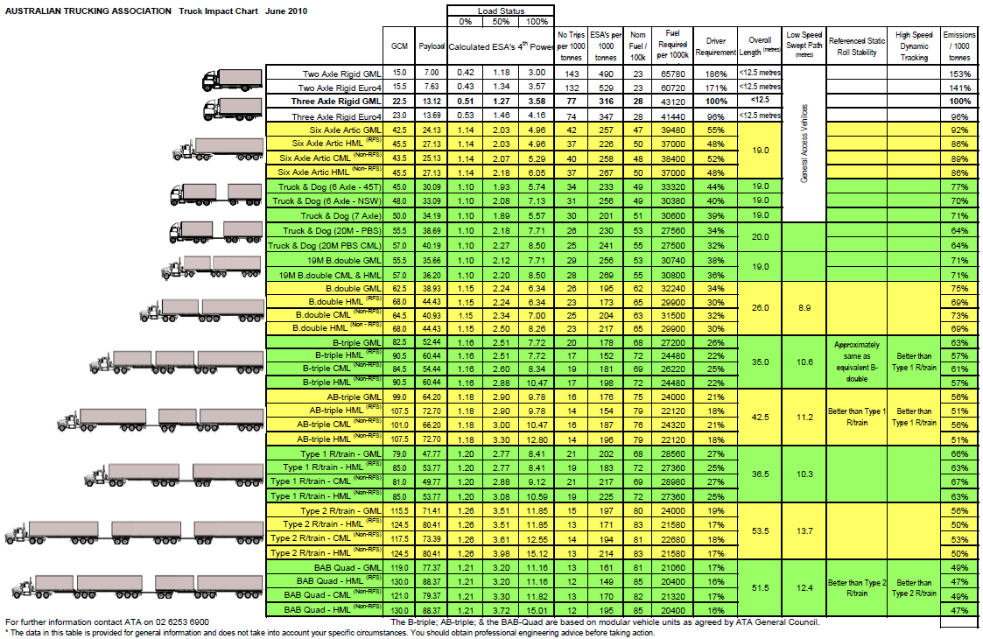

Considerable differences exist between NSW and VIC – Australian Logistics Council – The Costs of regulation disparity in cross border regions. Page 38
http://www.ntc.gov.au/filemedia/Groups/PBSmapsportalFAQ.pdf
Page 20 Infrastructure Australia – A report to the Council of Australian Government 2011
Page 22 paragraph 29 - ANAO Audit Report No.30 2009–10 Management of the Strategic Regional Program/Off-Network Program
Commonwealth Grant Guidelines: Policies and Principles for Grants Administration July 2009
Page 23 – paragraph 35 - ANAO Audit Report No.30 2009–10 Management of the Strategic Regional Program/Off-Network Program
Page 29 – paragraph 47 - ANAO Audit Report No.30 2009–10 Management of the Strategic Regional Program/Off-Network Program
Page 31 - paragraph 52- ANAO Audit Report No.30 2009–10 Management of the Strategic Regional Program/Off-Network Program
Page 22 – paragraph 32 - ANAO Audit Report No.30 2009–10 Management of the Strategic Regional Program/Off-Network Program
Page 22- paragraph 33 ANAO Audit Report No.30 2009–10 Management of the Strategic Regional Program/Off-Network Program
Page 40 - ANAO Audit Report No.30 2009–10 Management of the Strategic Regional Program/Off-Network Program
Page 41 - ANAO Audit Report No.30 2009–10 Management of the Strategic Regional Program/Off-Network Program
Page 43 - ANAO Audit Report No.30 2009–10 Management of the Strategic Regional Program/Off-Network Program
http://www.alga.asn.au/policy/transport/heavyvehicles/
Page 12 Issues Paper - Review of Access Pricing on the NSW Grain Line Network - May 2011 – IPART

