Submission to: | Business Regulation and Competition Working Group
Title: | Future COAG Regulatory Reform Agenda Stakeholder Consultation Paper
Date: | 21 October 2011

Contents

1. Introduction 3
2. Australian Trucking Association 3
3. Recommendations 4
4. COAG principles 5
5. Effects of restrictive regulation on the heavy vehicle industry 5
6. Improving sectoral competitiveness: how the industry interacts 6
7. Industry regulation 6
7.1. Heavy vehicle regulation in the service sector 7
7.2 Heavy vehicle regulation in the resources sector 8
7.3 Heavy vehicle regulation in the primary product sector 8
8. The National Heavy Vehicle Regulator. 9
9. Conclusion 9
APPENDIX A: The ATA and Barkwood Consulting Pty Ltd Truck Impact Chart 10

Introduction

The heavy vehicle industry has long called for consistent, productivity promoting and targeted regulation. With the heavy vehicle industry supporting many different industries in Australia, it cannot be underestimated how important removing unnecessary regulation, which has considerable impacts on the productive capabilities of the industry, is for the nation.

Recently the Minister for Infrastructure and Transport stated:

"You are the people who keep this country moving. You are the people who keep our towns and cities connected. You are the people who move goods from the farm gate to the factories, to the shops and the ports. It is not an exaggeration to say that the future prosperity of this country rests squarely on the shoulders of your industry. Because it is your industry that will be called on to meet and service the growth in interstate and international trade. Our international trade alone is scheduled to double by 2030, and triple by 2050."

Examples of regulation which limit the provision of a seamless national economy for the industry include:

- Restrictions on access – due to load mass or length of heavy vehicle.
- Permits – used to regulate access, they can apply to carrying dangerous goods, first and last mile access or other certain items.
- Lack of external review of access decisions.

COAG’s desire for a seamless national economy means they should focus attention on the heavy vehicle industry even thought there are renewed talks for rail to play a larger part in the freight task; the viability of rail will take many more years to be as productive and efficient as the road freight industry currently is. In the mean time, improving the productivity possibilities of the road freight industry should be the governments focus. The industry is fully prepared to access productivity gains, however, it is being reined in by restrictive regulation and poor decision making by local governments and road agencies.

Various programs industry has created have improved the productivity and safety of the fleet. For example, the Truck Safe programs outcome is that its members are twice as safe as non accredited operators. COAG should support safety promoting programs like Truck Safe, as encouraging this leads to better operator compliance and well maintained and safe heavy vehicles.

While industry strives to make its performance more efficient, the government’s regulators may have very different views of what regulation is to achieve. It is understandable why local governments would not want triple road trains operating in population dense areas; however, there are many routes which should be accessible to more productive, safer and longer vehicles (such as B-doubles and B-triples), which are currently not available to these vehicles.

The costs associated with oppressive regulation do not only affect operators of heavy vehicles. As the industry is a service provider, costs are likely to be passed onto client businesses and therefore, the end consumers of the good. Places that are difficult to access or costly admittance areas are less viable for businesses and likely to make the local government, where the restrictions apply, limited in the potential for growth in the community, as a direct result of restricting heavy vehicle access. There is no doubt that productive heavy vehicle access promotes economic growth in local government areas.

Australian Trucking Association

The Australian Trucking Association (ATA) is the peak body that represents the trucking industry. Its members include the state and sector based trucking associations, some of the nation’s largest transport companies, and businesses with leading expertise in truck technology.

Recommendations
Recommendation 1
The ATA recommends the COAG principles of national regulation should be used broadly on any reform which takes place, as consistent regulation which facilitates productivity is needed in order to create a national seamless economy.
Recommendation 2
The Business Regulation Competition Working Group (BRCWG) encourages the National Heavy Vehicle Regulator (NHVR) to allow the opportunity to seek external review of access decisions made by local government by including this in the national harmonisation of legislation.
Recommendation 3
The ATA recommends that the BRCWG should use the heavy vehicle industry as an example of where harmonised national regulation would lead to an increase in productivity.
Recommendation 4
The ATA recommends local government decisions which seek to restrict productivity should be reviewed and, where indentified, reversed.
Recommendation 5
We recommend the BRCWG note COAG should not progress with mass distance location pricing.
Recommendation 6
The ATA recommends COAG review its principle that there should be no-cross subsidisation between vehicle classes. This principle has led to productivity, safety and efficiency losses in the industry.
Recommendation 7
The ATA recommends that logistics should be able to react as flexibly as possible to demands in order to be optimally efficient. This requires regulations that facilitate productivity and include external review of access decisions to promote good judgment.
Recommendation 8
The ATA recommends regulation should be standardised on best practice to make sure it is as effective as possible.
Recommendation 9
The ATA recommends the BRCWG focus on the outcome of the NHVR to ensure regulatory uniformity is achieved, with a national law that facilitates productivity, innovation and sound accountable decision making.

COAG principles

Local government regulation regarding heavy vehicles is open to local amendment and there is limited or no tribunal review of decisions. This means regulation deviates from what was originally proposed and agreed to at Commonwealth/state level. The paper has indicated the sum of changing legislation unnecessarily weakens the effect of the regulation overall, and this is precisely what the industry has seen with access decisions.

The COAG national regulation principles should be taken into account with local governments and agencies over heavy vehicle decisions. The Business Regulation and Competition Working Group (BRCWG) paper sets out what reforms are required to produce, such as improved productivity by installing consistent regulation, and removing inefficient regulation. Local government planning decisions can be reviewed but access decisions cannot. This is unfair and denies the industry best practice decision making.

Reforming heavy vehicle regulation should be part of the examination by the working group as the industry is yet to see a fully formed and functioning National Heavy Vehicle Regulator (NHVR). At present the NHVR is in the process of creation, and the BRCWG should pay careful attention to ensure COAG directives of safety and efficiency are met. The inefficiency of non-national compliance by local governments which currently exists is not well targeted by the NHVR process. This will be a lost opportunity.

The ATA recommends the COAG principles of national regulation should be used broadly on any reform which takes place, as consistent regulation which facilitates productivity is needed in order to create a national seamless economy.

The Business Regulation Competition Working Group (BRCWG) encourages the National Heavy Vehicle Regulator (NHVR) to allow the opportunity to seek external review of access decisions made by local government by including this in the national harmonisation of legislation.

Effects of restrictive regulation on the heavy vehicle industry

In the heavy vehicle industry regulation which serves to impose an excessive cost on operators and businesses leads to a market failure due to less than optimal level of heavy vehicles accessing the local government area. There are two ways in which excessive regulation and indeed, differing regulation across councils, affects the way in which operators work.

The equilibrium is where the correct amount of regulation costs and the correct number of heavy vehicles accessing the local government area intersect. In reality, we find there is likely to be an undersupply of high productivity vehicles if regulation costs are higher than the equilibrium level.

In one case, operators will have to pay large sums of money to access permits, pay for access programs or install government monitored GPS. From the graph below the red line shows this effect, with less than optimal number of heavy vehicles with high productivity being provided to the area because of the high hurdle costs of regulation compliance involved.

On the other hand, operators may not be able to afford to pay for all the regulation which is necessary to access higher productivity vehicles, and may seek to use vehicles that comply with the most regulations at the lowest cost (orange line). This is likely to mean using semi-trailers or even less productive heavy vehicles that increase the impact on the infrastructure, due to more heavy vehicles being needed to complete the freight task rather than using high productivity vehicles.

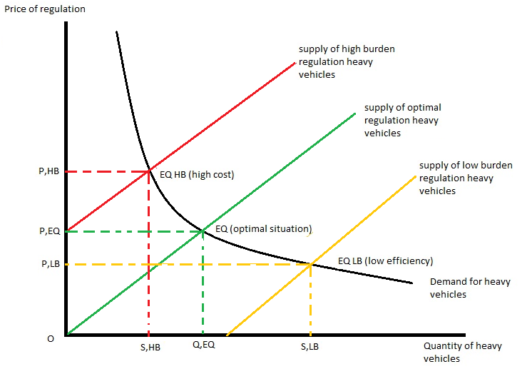

The aim of this working group is to examine which areas a national regulatory approach would be successful, and from the above model there is a considerable need for a national approach when planning regulation for the heavy vehicle industry in order to avoid an under or over supply or heavy vehicles for the freight task.

The ATA recommends that the BRCWG should use the heavy vehicle industry as an example of where harmonised national regulation would lead to an increase in productivity.

Improving sectoral competitiveness: how the industry interacts

Consumer fiscal tightening, occurring due to the effects of rising costs, and the impact of the global financial crisis, has placed increased pressure on industries such as the retail sector, agriculture and resources. This means the economic outlook for these industries is even more competitive with companies jostling for income and market share.

The increase in the presence of imports due to the strengthening dollar over the past decade has meant competition for market share has become even more acute. Hence, there is increased pressure to improve the current failings of the regulatory procedures which impose unnecessary costs on the heavy vehicle industry and on the businesses that utilise heavy vehicles in order to make Australian goods as competitive as possible.

The paper notes rural Australia can benefit from improved competitiveness and productivity of sectors not connected to them due to flow on benefits. Accessing these productive benefits is diminished by local government’s failure to allow access for high productivity vehicles, which limit the growth of businesses in their own jurisdiction. Regulation that applies to transforming rural Australia should be examined with great scrutiny to make sure those in charge of the jurisdiction are focussed on growing the potential of their communities, not keeping them static.

Industry regulation

Articulated vehicles can access higher mass limits (HML) through road friendly suspension (RFS) which allow for higher mass to be carried with the same amount of road impact of a non-RFS vehicle at general mass limit (GML). Permits are still required by some local governments for this scheme even though the damage caused by these heavy vehicles is the same as other heavy vehicles that can access the same route without permits; and complete the freight task in fewer trips. Local governments that use permits as a barrier to their jurisdiction should have their powers in this area revoked.
These permits serve to constrain the productivity of businesses which operate in their jurisdiction and impose a significant charge on production costs. This also has effects on the viability of the jurisdiction, as areas where inherent costs of logistics are more expensive will lead to businesses seeking local government areas that are more flexible and allow for productivity boosting heavy vehicles to access roads. However, in most cases it is not simple for businesses to just move to areas with better access, especially livestock, wineries, other farmers, miners and other location sensitive industries.

If genuine competition is to exist in Australia the abolishing of excessive regulation will lead to increased efficiency and a level playing field for producers of all goods.

Along with the problem mentioned above, the current COAG Road Reform Plan (CRRP) sets to cause further distress to the industry and businesses which depend on heavy vehicles. CRRP seeks to implement mass, distance and location (MDL) charging. This requires expensive technology to be fitted to all heavy vehicles, and CRRP have yet to specify who will pay for installation, updating and retrofitting. It is set to cost thousands of dollars per operator. MDL charging will disadvantage rural Australia as the cost of using rural roads will incur higher maintenance costs. Concerns have been raised by farming organisations and other industries over this effect. The CRRP process is a perfect example of how regulation can stunt the capability of the country by implementing charging that fails to support productivity.

The COAG principle of no-cross subsidisation in heavy vehicle classes has led to the A-trailer registration fee, which is a main component of B-doubles, B-triples and BAB quads, rising roughly by $5000 per trailer to reflect this principle. The effects on the industry have been debilitating, with the ATA and other industry representatives working closely with the NTC to solve the problem the A-trailer registration fee increase has caused. Examples such as A-trailers being registered as semi trailers (a third according to the NTC), operators struggling to pay the exorbitant registration and many operators simply having to use less productive heavy vehicles have become apparent. There are considerable safety issues raised by the industries moving away from longer, safer, more productive combinations, and the future of the industry if the crisis continues. One of the main ways which has been suggested to solve the problem is the ATA per axle charge, which may use cross subsidisation between trailers, but would avert a disaster for the industry and for the productivity of the nation. Therefore, the principal of no cross-subsidisation is standing in the way of promoting efficiency in the heavy vehicle industry.

The ATA recommends local government decisions which seek to restrict productivity should be reviewed and, where indentified, reversed.

We recommend the BRCWG note COAG should not progress with mass distance location pricing.

The ATA recommends COAG review its principle that there should be no-cross subsidisation between vehicle classes. This principle has led to productivity, safety and efficiency losses in the industry.

7.1. Heavy vehicle regulation in the service sector

The industry experiences many impediments when delivering to cities across Australia. Congestion created by light vehicles causes costs for operators due to longer travel time, increased fuel use and missed deadlines. This leads to operators trying to deliver goods outside busy times. However, some local governments put curfews on operators as indicated by this paper. The restrictions are due to noise and light disturbances and the paper rightly points out many local governments simply chose to stamp restrictions on heavy vehicles without examining any other externalities that cause noise and light pollution to the community at night.

The flexibility of night time delivery would mean heavy vehicles would not have to travel in congested areas and miss deadlines and would improve the safety of the fleet by operating at a time when less light vehicles are on the roads. It should be noted that 82% of multiple vehicle crashes involving a heavy vehicle are caused by the non-heavy vehicle driver, so removing light passenger vehicles from the road lowers the actual risk of heavy vehicle crashes.

Allowing longer, safer, more productive heavy vehicles access to local government roads reduces the number of heavy vehicles required to carry out the freight task. For instance, a 6 axle Semi-trailer will take 42 trips to move 1000 tonnes of goods, whereas a 9 axle B-double can do the same task in 26 trips, and one fitted with road friendly suspension in 23 trips. Therefore, fewer heavy vehicles are on the road, impact to infrastructure is less, and safer combinations are operating on our roads.

The heavy vehicle industry and companies which need to use heavy vehicles are constantly confronted with ill-founded ideas about the effects of larger heavy vehicles. People see large heavy vehicles simply as bigger, heavy vehicles not safer, more productive, less damaging heavy vehicles. There needs to be a re-education, especially of those who make road provision and access decisions in order to encourage the productive nature of the economy. Provision of external review of decisions is an established method of improving decision making.

It should also be noted the environmental credentials of the industry are improving year on year, and the difference between the performance of a B-double and a semi-trailer for the given freight task above is a B-double produces three-quarters the emissions of a semi-trailer to complete the same freight task.Emissions of carbon monoxide, hydrocarbons, nitrogen oxides and particulates from new engines fell dramatically between 1995 and 2010.

The ATA recommends that logistics should be able to react as flexibly as possible to demands in order to be optimally efficient. This requires regulations that facilitate productivity and include external review of access decisions to promote good judgment.

7.2 Heavy vehicle regulation in the resources sector

Movements in the resources sector can require permits because of the nature of the goods carried; generally they are indivisible, large, bulky machinery. While this is increasingly necessary for safety’s sake, the system is far from effective, as there is a significant overlapping difference in what is compulsory for operators in different local government areas.

For instance, a mining company finds it better for business to move resources by short sea shipping between Queensland and New South Wales rather than using heavy vehicles. NSW does not permit the larger vehicles to operate on the road and would require significant de-coupling of heavy vehicles in order to access its roads. Short sea shipping takes more time, has a higher cost and means that heavy vehicles have to travel to port and back again, however, for the mine it is a more attractive way to move freight compared to using heavy vehicles because of the regulation.

The ATA recommends regulation should be standardised on best practice to make sure it is as effective as possible.

7.3 Heavy vehicle regulation in the primary product sector

The agricultural industry relies a great deal on the heavy vehicle industry as the prime mode of transport for the majority of goods produced. Many places cannot access high productivity vehicles due to the lack of road access. Local governments can provide quotes on how much it would cost to upgrade, however, past cases have show there can be considerable differences between private and local government quotes, with private quotes being cheaper. Concerns exist over the cost-effective nature of local governments in providing the most competitive price for road provision. This directly affects the productive capacity of the business which produces goods.

Agricultural goods producers come up against pressures such as ensuring their produce arrives as fresh as possible to buyers, and restriction of hours of delivery limits the flexibility of delivering goods at their optimum. Also many orchards and market gardens are becoming engulfed by residential suburbs which mean that access granted to heavy vehicles is becoming an issue due to community pressure.

Having a strong export presence is an economic essential for Australia. The livestock export market plays a substantial role in Australia’s export income. Regulation that seeks to limit the productivity of livestock movements will have significant effects on the export status of Australia. Transporting humanely, quickly and efficiently as possible will mean that animals are in better condition for export.

As noted in this section there are many areas for improvement in the function of regulation and the sectors mentioned here are just the tip of the iceberg. Any industries that uses logistics has to consider regulation and road provision decisions.

The National Heavy Vehicle Regulator.

If the productive possibility of the industry is to be met then there has to be a culture change around local governments altering regulation to suit their own wishes, industry innovation for productivity should be nurtured. Currently a National Heavy Vehicle Regulator is being created and should address some of the specific areas that we have mentioned above.

Specifically the NHVR should put an end to disconnected, subjective and inefficient regulation as well as making the cost and use of permits more transparent for operators across the nation.

The heavy vehicle industry is hoping this reform, which is dependent on each state agreeing to uniform heavy vehicle regulation, will deliver better outcomes. The potential for cost-efficient savings made by operators and industry are large, so it is vital the process is taken seriously by those creating the regulation.

Industry is involved in consultation with the NHVR, but there are fears that industry could be left with unmet expectations. This enhances the concern that the Australian federal system will never be able to enforce uniformity with best practice regulation, as states and local government will fight hard for their own determination of regulations and to be above investigation. For example, agencies are refusing to allow the national law to provide external review of access decisions.

The ATA recommends the BRCWG focus on the outcome of the NHVR to ensure regulatory uniformity is achieved, with a national law that facilitates productivity, innovation and sound accountable decision making.

Conclusion

While the National Heavy Vehicle Regulator is in the process of being created, the industry can still do with greater productivity incentives. The NTC has recently recommended agencies support the use of B-triples, they are larger than B-doubles, carry more and are a safer combination than road trains. While the NHVR can enforce uniform regulation, the industry needs the Commonwealth and ministers to push for more productive vehicles to access state and local government areas.

The work of the Business Regulation and Competition Working Group has identified sectors that need regulatory improvements, however, improving the one thing which nearly all sectors of Australia’s industries use, heavy vehicles, would provide the greatest benefit.

APPENDIX A: The ATA and Barkwood Consulting Pty Ltd Truck Impact Chart

The ATA and Barkwood Consulting Pty Ltd have developed a Truck Impact Chart that clearly demonstrates a number of different heavy vehicle combinations and covers GCM, payload, the equivalent standard axles (ESAs) for each vehicle combination, being the measure by which impact of a truck on the road is measured, the amount of trips required to move 1,000 tonnes of freight, the amount of fuel required to move 1,000 tonnes of freight, emissions and driver requirement. The information provided in the tables throughout this document is taken from the Truck Impact Chart.

The Truck Impact Chart has been reviewed RTA’s Senior Pavement Engineer, Ravindra Prathapa. The Truck Impact Chart has also been separately peer reviewed by Bob Pearson, Pearson Transport Resources, and was referred to by TheCIE in the Benefit/Cost Analysis for the National Heavy Vehicle Regulator draft Regulatory Impact Statement, released in February 2011.

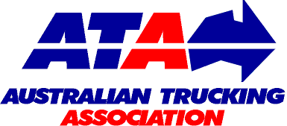 | Authors: | David Coonan - Australian Trucking Association | BARKWOOD CONSULTING Pty Ltd
 |  | Bob Woodward - Barkwood Consulting Pty Ltd.
This document has been prepared to assist operators and road asset managers in assessing the merits of utilising larger vehicle combinations in a transport task.
The assessment process assumes that the vehicle is dedicated to a specific task, operating travel being 50% unladen and 50% laden. The task relativities are 1000 tonnes with a lead of 1000 kilometres.
Equivalent Standard Axles: | ESA’s are calculated by the average of the sum of ESA’s for zero load (empty) plus ESA’s for 100% load and multiplied by the number of trips as required for the transport task.
Vehicle tare weights: | Are predictions based on the averages for a range of equipment within each combination category. These estimates have been reviewed by a number of operators and confirmed as being representative of “real” vehicles of the category.
Fuel consumption estimates: | Are predictions based on accumulated averages where operation is nominally 50% unladen and 50% laden. Actual consumption will vary with operating conditions.
Emissions: | Reference is based on total fuel consumption only.
20 metre 7 axle Truck & Dog: | The maximum allowable mass limits for this combination at either CML or HML (for standard combination) is 55.5 tonnes.
19 metre 7 Axle B-double: | The maximum allowable mass limits for this combination at either CML or HML (for standard combination) is 55.5 tonnes.
B-triple: | Consists of a complying B-double with an additional complying leading trailer.
Converter Dolly: | All combinations utilizing a converter dolly are configured with a tandem axle. The configured vertical imposed loading of a 6x4 prime mover is similar to the allowable imposed vertical loading of a tandem axle converter dolly.
AB-triple: | Consists of a complying B-double with an additional complying road train leading trailer and a complying converter dolly.
BAB-Quad: | Consists of a complying B-double with an additional complying converter dolly and additional complying set of B-double trailers.

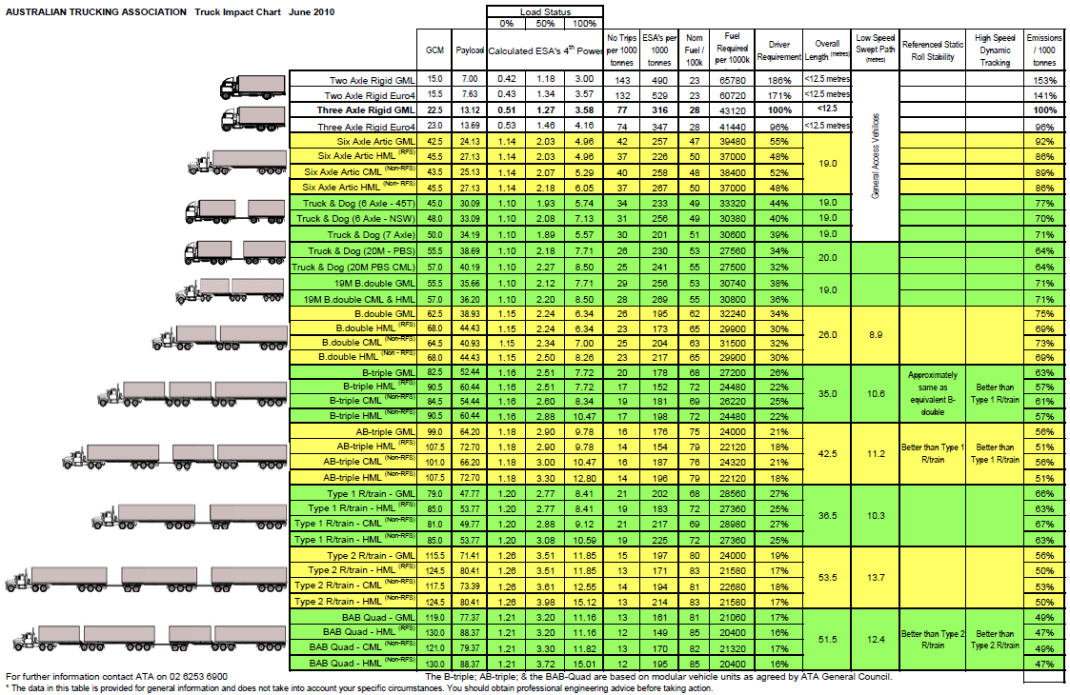

From an address by the Hon Anthony Albanese MP. Minister for Infrastructure and Transport. Australian Trucking Convention, Canberra 2011
http://trucksafe.files.wordpress.com/2010/12/the-case-for-trucksafe1.pdf - page 7
The Australian Logistics Council – The Cost Impact of Regulation in Cross Border Regions - page 16 – the case of the wineries in the Mildura region
National Transport Insurance (NTI) accident research centre http://www.nti.com.au/AboutNTI/NewsandMedia/tabid/85/newsid468/17/mid/468/Default.aspx
See Truck Impact Chart attached.
See Truck Impact Chart attached
Page 3 - Draft clean energy legislative package to Department of Climate Change and Energy Efficiency – the ATA – 22 may 2011

