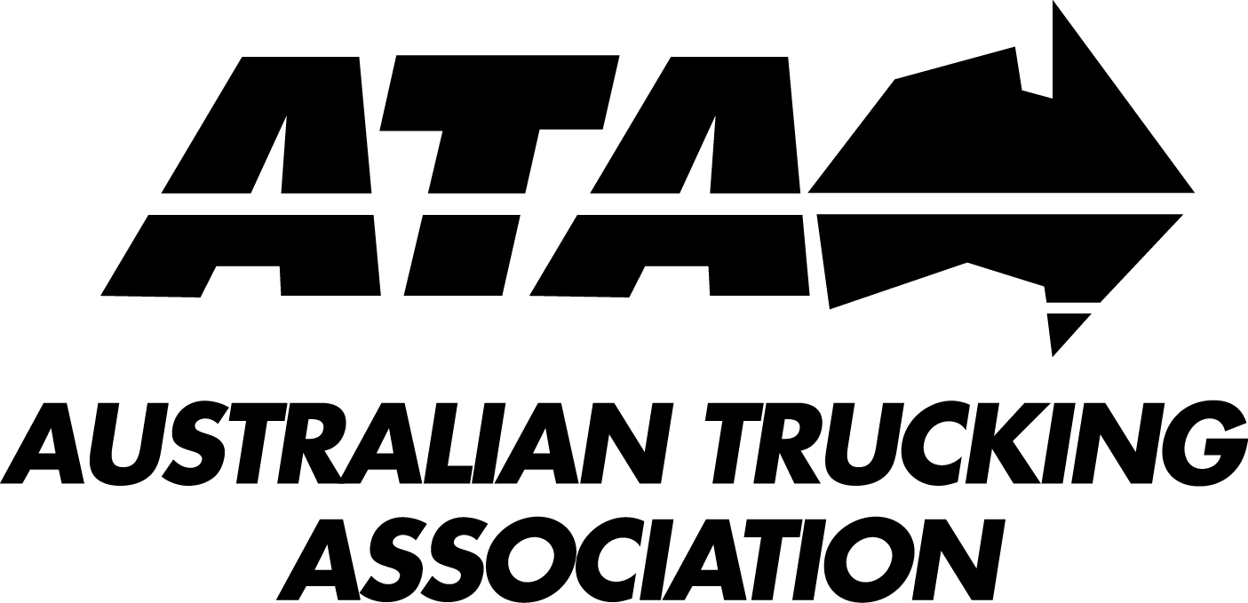

EXECUTIVE OFFICER DUE DILIGENCE OBLIGATION CONSULTATION RIS
AUSTRALIAN TRUCKING ASSOCIATION RESPONSE
22 APRIL 2016

Introduction

In November 2015, transport ministers agreed to series of reforms to the Heavy Vehicle National Law (HVNL), including the introduction of a positive due diligence obligation for executive officers to ensure chain parties comply with their primary safety duty.

Ministers also agreed to extend the executive officer due diligence obligation to include any person with a duty or obligation under the HVNL, subject to the outcomes of the RIS under consideration in this submission.

The RIS examines four options:

- Impose a positive due diligence obligation on executives in relation to CoR issues; executive officer liability for non-CoR offences would not be changed, although the burden of proof for the remaining offences listed in column 3 of schedule 4 would be imposed on the prosecution
- Remove executive officer liability for all non-CoR offences
- Extend the due diligence obligation for CoR offences to cover the non-CoR offences listed in the schedule
- Extend the due diligence obligation to cover the executive officers of any party with a duty or obligation under the HVNL.

ATA assessment of options

Option 1

Under option 1, the HVNL would include two mechanisms for extending liability to executive officers:

- a positive due diligence obligation for executive officers to ensure chain parties comply with their primary safety duty and
- a modified version of the existing s 636(2) approach to executive officer liability, which would apply to the 34 non-CoR offences that would be listed in column 3 of schedule 4 only.

There are arguments for and against both these approaches to executive officer liability, but nothing can be said in favour of having both of them in the same piece of legislation. Option 1 would unnecessarily complicate the development of corporate safety systems and should not be adopted.

Option 2

Option 2 would remove executive officer liability for non-CoR offences. Section 636(2) of the HVNL would be repealed, as would the list of offences in column 3 of schedule 4.

The option would reduce the scope of executive officer liability across the law. It would mean that officers would no longer be personally liable for taking steps to prevent a number of serious safety offences, including offences related to:

- vehicle registration, although it should be noted that the vehicle registration chapter of the HVNL has not yet come into effect
- operating an unsafe heavy vehicle
- contravening conditions of mass or dimension exemptions
- tampering with a speed limiter fitted to a heavy vehicle
- tampering with an approved electronic recording system.

Executive officers of chain parties would nonetheless have a due diligence obligation to ensure compliance with their primary safety duty.

The ATA is particularly concerned that the option would remove executive officer liability for speed limiter tampering, at least as far as non-chain parties are concerned.

Research shows that travelling just 10 km/h faster on rural roads than the average speed of other traffic doubles the risk of involvement in a crash. Speeding also increases the severity of crashes when they occur.

Governments mandated speed limiters in 1990 because it was recognised that conventional speed enforcement methods were not sufficient to secure compliance. Although the trucking industry’s speed compliance is steadily improving – for example, the number of heavy vehicles detected speeding by the NSW Safe-T-Cam system fell 95 per cent between 2011 and 2014 – this is not the time to weaken the laws.

Overall, the ATA strongly agrees with the RIS that option 2 has the potential to reduce safety outcomes in the industry. Option 2 should not be considered further.

Option 3

Under option 3, executive officers would be required to undertake positive due diligence in relation to the non-CoR offences listed under column 3 of schedule 4, in addition to their due diligence obligations with respect to CoR compliance. The RIS notes that the non-CoR offences are being modified to remove the current reverse onus of proof and place the burden of proof on the prosecution.

The ATA supports this option. As the RIS points out, it would create a consistent approach to executive officer liability across the HVNL. It would encourage higher levels of compliance and therefore safety.

Option 4

Option 4 would extend the due diligence obligation to include anyone with a duty or obligation under the HVNL. According to the RIS, the option would extend the liability of executive officers to include some 200 additional offences.

The ATA does not support option 4. Despite the arguments in the RIS, it would not increase safety and could in fact reduce it. It would increase the compliance burden on business and would not be consistent with the other national safety laws.

In assessing option 4, the ATA has drawn on the COAG principles and guidelines for personal liability for corporate fault.

The RIS argues that the COAG principles do not apply, because the executive officer involved would personally commit the offence of failing to undertake due diligence. But the COAG principles are clearly intended to apply to situations where officers have a due diligence obligation. For example, section 2.3 of the guidelines states that:

The Directors’ Liability Provisions that are relevant to applying the COAG Principles are those that go beyond normal accessorial liability.

Generally speaking these are provisions which extend liability by also holding directors liable where they have been negligent in relation to the corporation’s contravention. While different language is sometimes used, what is common about these provisions is that they provide that a director or other officer will be liable if they were “negligent”, or failed to take “reasonable steps”, or failed to exercise “due diligence”, to avoid or prevent the corporation’s contravention.

[emphasis added]

In any case, the RIS itself has a bet each way on the applicability of the guidelines, since part of its case for option 3 is that all the offences that would be included under the option were recently assessed.

Impact of option 4 on safety

The RIS argues that option 4 would improve safety because it would extend the scope of executive officer responsibility to cover some serious safety-related offences where executive officers do not currently have any liability.

The COAG guidelines require a rigorous and transparent assessment to demonstrate that a compelling public policy reason exists to extend liability for these offences.

The RIS fails to meet this requirement. It only cites one example of such an offence: section 228, which imposes a duty on drivers to avoid driving while fatigued. According to the RIS, option 4 would mean that executive officers would need to ensure corporations had systems in place to prevent fatigue breaches.

But executive officers already have this obligation under multiple provisions in chapter 6, and will in future have this obligation under their general due diligence obligation. Implementing option 4 would simply add complexity and duplication to the obligations that officers already have.

As a result of the additional complexity involved in option 4, the ATA considers that it could achieve the perverse result of reducing safety compliance rather than increasing it.

The effectiveness of executive officer liability depends on its being imposed on a manageable number of serious offences. As the COAG guidelines point out:

If Directors’ Liability is imposed on too many offences, some of which are serious and some of which are not, then the imposition of such liability fails to serve as an effective signal to directors as to the few particular offences which society considers to be of such seriousness as to justify a higher level of personal diligence and risk-avoidance behaviour on the part of corporate boards.

Option 4 has exactly this problem: it would swamp critically important safety obligations under a requirement for executive officers to exercise due diligence to prevent an overwhelming number of less serious offences.

Impact of option 4 on compliance costs

Option 4 would increase the compliance burden on businesses by requiring executive officers to exercise due diligence to prevent a much greater range of offences than at present.

The RIS concedes that these offences are often less serious than those covered by the existing s 636(2) provisions and that many are administrative in nature. They include offences relating to:

- replacing defaced, lost or stolen permits
- using the correct time zone in a driver’s work diary and
- providing information to work diary record keepers within 21 days

It is not at all clear why an executive officer – who might be a part time, independent director – should be personally liable for exercising due diligence to prevent such administrative offences, when the officer should be focusing on broader safety and business concerns.

Under option 4, executive officers would also bear a due diligence obligation to prevent offences by employees, such as:

- disobeying a direction to move or leave a heavy vehicle
- refusing to provide a name, address and date of birth and
- obstructing an authorised officer.

Again, it is hard to see what an executive officer could do, in advance and from a distance, to manage the sort of dispute between an employee and an enforcement officer that would be likely to lead to charges like these being laid.

Consistency with other national safety laws

The RIS argues that option 4 would be ‘similar in application’ to the requirements placed on executive officers under the RSNL and the Model WHS Act. This argument is incorrect: option 4 would go well beyond the requirements of the other national safety laws.

WHS Act

The due diligence obligation under section 27(1) of the WHS Act states:

If a PCBU has a duty or obligation under this Act, an officer of the PCBU must exercise due diligence to ensure that the PCBU complies with that duty or obligation.

“This Act” is defined in section 4 of the WHS Act (or, in some jurisdictions, in Interpretation Acts) to include both the WHS Act and the WHS Regulations. Accordingly, the due diligence obligation extends to ensuring that the PCBU complies with its duties and obligations under both the WHS Act and WHS Regulations.

The due diligence obligation does not, however, extend to ensuring that natural persons working for the PCBU comply with their obligations under the WHS Act and WHS Regulations. This distinction can be demonstrated using the following example:

In the context of high risk work which requires a high risk work licence, an officer’s due diligence obligation:

(a) includes exercising due diligence to ensure that the PCBU sees written evidence that a worker has the relevant licence before allowing the worker to carry out the high risk work. This is because the duty is imposed on the PCBU under reg 85 of the WHS Regulations;

(b) does NOT include exercising due diligence to ensure that the individual licence holder keeps their licence document available for inspection under the WHS Act. This is because the duty is imposed on the individual licence holder under reg 94 of the WHS Regulations.

Rail Safety National Law

The due diligence obligation under section 55 of the RSNL states:

If a person has a duty or obligation under this Law, an officer of the person must exercise due diligence to ensure that the person complies with that duty or obligation.

“This Law” is defined to include statutory instruments made under the RSNL. Accordingly, the due diligence obligation extends to all duties and obligations held by “the person” under the RSNL and associated regulations.

The difference between the due diligence obligation under the RSNL and the WHS Act is that the WHS Act imposes the obligation on officers of a PCBU (and therefore, the duty extends to duties held by the PCBU), whereas the RSNL imposes the obligation on officers of a person (and therefore, the duty extends to duties held by the person).

Ordinarily, a reference to a “person” in legislation includes both a body corporate and a natural person. However, having regard to the definition of “officer” under the RSNL, it is not possible for someone to be an officer of a natural person.

Accordingly, where the due diligence obligation under the RSNL refers an “an officer of the person,” the ATA considers it has to be read as “an officer of the organisation.”

In light of the above, the breadth of the due diligence obligation under the RSNL is the same as under the WHS Act. Both national safety laws require an officer of an organisation to exercise due diligence to ensure that the organisation complies with its duties and obligations. Neither law goes as far as option 4 and requires officers to exercise due diligence to ensure that natural persons comply with their obligations.

Summary of expected impacts from option 4

Given the above assessment, the ATA considers that table 5 in the RIS should be recast as follows:

Type of impact | Compliance costs | Safety impacts | Administrative costs
Qualitative assessment | - Increase in the scope of executive officer liability  - Potential for an increase in compliance costs  - Any increase will be limited due to the existing requirements of executive officers under the HVNL and the Model WHS Act  - Any increase will be worsened by the inconsistency of this option with the model WHS Act.  - Guidance materials will be required to minimise implementation costs  - Option inconsistent with relevant COAG principles and guidelines. | - Potential for improvements in safety due to removal of doubt about executive officer responsibility for compliance and reduced complexity  - No evidence provided in the RIS that the option captures serious safety-related offences that are not already captured  - Widening the scope of liability may increase regulatory complexity and reduce safety | - Modest reductions in the cost of investigating and prosecuting executive officers  - Potential for some implementation costs

ATA recommendation

Governments should adopt option 3 in the consultation RIS.

NTC, Heavy Vehicle National Law – Extension of Executive Officer Due Diligence Obligation Regulatory Impact Statement. Draft for public consultation, March 2016, 13. Link.
NTC, 20.
NTC, 21.
s 30(1).
s 89(1).
ss 129(1)-(3).
ss 93(1)-(3).
s 335(1); s336(1).
Kloeden CN, McLean AJ, “Rural speed and crash risk,” Proceedings of the 2001 Road Safety Research, Policing and Education Conference, 163-168 (vol 2).
Saulwick, J. Victorian failure to monitor dangerous trucks putting NSW drivers at risk, Sydney Morning Herald, 28 September 2015.
NTC, 32.
NTC, 34.
Council of Australian Governments (COAG), Personal liability for corporate fault—guidelines for applying the COAG principles, COAG, Canberra, 2012. Available at <www.coag.gov.au/node/434>.
NTC, 35.
NTC, 33
NTC, 35.
COAG guidelines, s 4.1(4)(a)
NTC, 34.
COAG, Annexure A: interpreting the COAG principles, 4a.
NTC, 34.
s 80(1).
s 303.
s 322(2)
ss 517(4), 524(5)
s 567(4)
s 584(1).
NTC, 34.
Officer – (a) in relation to a body corporate, has the same meaning as officer has in relation to a corporation under section 9 of the Corporations Act 2001 of the Commonwealth; (b) in relation to any other person, means an individual who makes, or participates in making, decisions that affect the whole, or a substantial part, of the business or undertaking of the person.

