Report: | Assessment of Actual Heavy Vehicle Registration Population Data against the NTC PayGo Model
Date: | 19 June 2012

Contents

1. Introduction 3
2. Australian Trucking Association 3
3. State and Territory Request for Information 4
3.1. Australian Capital Territory 4
3.2. New South Wales 5
3.3. Northern Territory 6
3.4. Queensland 7
3.5. South Australia 8
3.6. Tasmania 9
3.7. Victoria 10
3.8. Western Australia 11
4. National Totals and NTC Data 12
4.1. National 12
4.2. NTC Data 13
5. Outcomes 14
6. Appendices 16
6.1. Appendix A – Tables provided to state and territory road authorities for completion based on the information in relevant registration databases. 16
6.2. Appendix B – NTC Heavy Vehicle Registration Charges to commence 1 July 2012 18
6.3. Appendix C – Tables provided by ACT Government 19
6.4. Appendix D – Correspondence received from NSW RMS 20
6.5. Appendix E – Tables provided by NT Dept Lands & Planning 24
6.6. Appendix F – Tables provided by Qld Dept Transport and Main Roads 26
6.7. Appendix G – Correspondence received from SA DPTI 28
6.8. Appendix H – Correspondence received from TAS DIER 30
6.9. Appendix I – Tables provided by VicRoads 31
6.10. Appendix J – Tables provided by WA Dept of Transport 33

Introduction

This report explores the information provided by state and territory road agencies. It also examines the estimated revenue to be generated using the NTC’s determined registration charges to commence on 1 July 2012, and compares this to the PayGo Charges Model estimates of revenue.

The National Transport Commission (NTC) is responsible for determining the new registration charges for heavy vehicles each year. The charges relate to registration fees imposed on trucking operators for the use of their vehicles on Australian roads. The calculation attempts to recover the cost attributable to heavy vehicles using roads.

The NTC is also responsible for determining the annual adjustment to the fuel tax rebate. Both determinations use a complex and involved Excel spreadsheet known as the PayGo Charges Model. A number of inputs and assumptions are made within the PayGo Charges Model to arrive at the recommended registration charges for a particular year.

The NTC relies on data from the Australian Bureau of Statistics, namely from the Survey of Motor Vehicle Use and the Motor Vehicle Census, both of which carry heavy disclaimers about using the data for purposes other than what it was collected for. Using the ABS data and inputting it into the PayGo Charges Model, the NTC claims there are 392,453 heavy vehicle combinations in Australia, which may be made up of one, two, three or more, registered heavy vehicle units. The NTC use averages across seven years’ worth of ABS data to determine the registered heavy vehicle population in Australia. Where no data was collected (such as in 2008), the NTC introduces a trend formula to estimate the registered heavy vehicle population. Unfortunately, these assumptions grossly under-estimates the number of heavy vehicles actually registered.

The ATA has challenged this information in the past, and has now taken the step of requesting registration population data from state and territory road authorities, who capture this data in their registration database systems. The requests to road agencies were via formal applications or FoI requests based on the relevant state or territory legislation. General correspondence or application forms were completed, with a request to complete two tables for the ATA – one capturing heavy vehicles that were registered under the Federal Interstate Registration Scheme (FIRS) and one capturing heavy vehicles that were not registered under FIRS. The point in time of collection of the data was 31 December 2011. A copy of the tables requested to be completed are attached at Appendix A.

A copy of the heavy vehicle registration charges agreed to by the Standing Council of Transport and Infrastructure (SCOTI) ministers in May, and due to commence on 1 July 2012, is attached at Appendix B. However, it should be noted that states and territories are not beholden to the NTC figures, and may adjust their state based registration charges according to their own treasury advice, which some have done.

It should be kept top of mind that heavy vehicle registration charges were developed to recover road related expenditure attributable to heavy vehicle use, and were not designed to generate revenue beyond that. Revenue that is generated by heavy vehicle registration charges beyond the road related expenditure attributable to heavy vehicles is unfair and not in keeping with the decisions of COAG.

Australian Trucking Association

The Australian Trucking Association (ATA) is the peak body that represents the trucking industry. Its members include the state and sector based trucking associations, some of the nation’s largest transport companies, and businesses with leading expertise in truck technology.

State and Territory Request for Information
  - Australian Capital Territory
Formal correspondence was mailed to the Department of Transport on 13 February 2012. A cheque of $29.50 was required to be paid for the request.

The information as requested was received on 23 February 2012. A copy of the tables received is attached under Appendix C. The total heavy vehicle registration population data, including FIRS vehicles, is as follows:

- ACT – total registered heavy vehicle population

DIVISION 1 – LOAD CARRYING VEHICLES
Vehicle Type | 2 axle | 3 axle | 4 axle | 5 axle
Trucks
Truck (type 1) | 996 | 5 | 0 | 0
Truck (type 2) | 273 | 287 | 77 | 7
Short combination truck | 15 | 57 | 3 | 0
Medium combination truck | 0 | 38 | 3 | 0
Long combination truck | 0 | 0 | 0 | 0
Prime Movers
Short combination prime mover | 12 | 123 | 0 | 0
Multi-combination prime mover | 0 | 29 | 0 | 0
DIVISION 2 – LOAD CARRYING TRAILERS
Trailer Type | Single | Tandem group | Tri-axle group | Quad group
Pig Trailer | 20 | 9 | 0 | 0
Dog Trailer | 24 | 88 | 11 | 0
Semi Trailer | 55 | 54 | 1 | 0
B-double lead trailer and B-triple lead and middle trailers | 1 | 11 | 0 | 0
Converter dolly or low loader dolly | 0 | 0 | 0 | 0
DIVISION 3 - BUSES
Bus Type | 2 axle | 3 axle | 4 axle
Bus (type 1) | 167 | 0 | 0
Bus (type 2) | 394 | 41 | 0
Articulated bus | 0 | 33 | 0
DIVISION 4 – SPECIAL PURPOSE VEHICLES
Special purpose vehicle (type P) | 141
Special purpose vehicle (type T) | 81
Special purpose vehicle (type O) | 43

Using the above registered heavy vehicle population data, the estimated revenue using the new NTC charges noted in Appendix B is $3m. According to the NTC, the total amount required to be recovered by ACT to recover the expenditure attributable to heavy vehicles was $4m. This means, the ACT government would, in effect, under-recover by $0.8m if it applied the NTC determined charges without change. Under-recovery is unique to the ACT.

  - New South Wales
Formal correspondence was mailed to Roads and Maritime Services by Australia Post on 31 January 2012. A cheque of $30 was required to be paid for the request.

The information as requested was received on 23 February 2012. A copy of the correspondence received is attached under Appendix D.

The information provided by RMS was involved. Further consultation and communication was undertaken with Mr Wayne Kosh by telephone and email to ensure the data was interpreted correctly. The total heavy vehicle registration population data, including FIRS vehicles, is as follows:

- NSW – total registered heavy vehicle population

DIVISION 1 – LOAD CARRYING VEHICLES
Vehicle Type | 2 axle | 3 axle | 4 axle | 5 axle
Trucks
Truck (type 1) | 46,662 | 408 | 5 | 0
Truck (type 2) | 13,349 | 12,507 | 2,602 | 0
Short combination truck | 2,600 | 3,842 | 488 | 0
Medium combination truck | 20 | 2,987 | 280 | 0
Long combination truck | 0 | 8 | 4 | 0
Prime Movers
Short combination prime mover | 1,098 | 11,886 | 20 | 0
Multi-combination prime mover | 26 | 5,761 | 5 | 0
DIVISION 2 – LOAD CARRYING TRAILERS
Trailer Type | Single | Tandem group | Tri-axle group | Quad group
Pig Trailer | 656 | 1,460 | 415 | 6
Dog Trailer | 0 | 830 | 3,577 | 710
Semi Trailer | 691 | 4,326 | 19,517 | 280
B-double lead trailer and B-triple lead and middle trailers | 3 | 643 | 2,605 | 7
Converter dolly or low loader dolly | 17 | 1163 | 68 | 23
DIVISION 3 – BUSES
Bus Type | 2 axle | 3 axle | 4 axle
Bus (type 1) | 4,154 | 0 | 0
Bus (type 2) | 0 | 7,306 | 0
Articulated bus | 0 | 266 | 0
DIVISION 4 – SPECIAL PURPOSE VEHICLES
Special purpose vehicle (type P) | 3,972
Special purpose vehicle (type T) | 3,078
Special purpose vehicle (type O) | 1,120

There were also the following unusual axle grouped trailers:

Dog Trailer – 5 axles | 1
Semi Trailer – 5 axles | 6
Semi Trailer – 6 axles | 6
Semi Trailer – 8 axles | 3

Using the above registered heavy vehicle population data, the estimated revenue using the new NTC charges noted in Appendix B is $277m. According to the NTC, the total amount required to be recovered by NSW to recover the expenditure attributable to heavy vehicles was $201m. This means, the NSW government would, in effect, over-recover $76m if it applied the NTC determined charges without change.
  - Northern Territory
Formal correspondence was emailed to the Department of Lands and Planning on 20 January 2012. A payment of $104 was made via telephone using a credit card once a verbal quotation was provided as to the cost of the request.

The information as requested was received on 13 March 2012. A copy of the tables received is attached under Appendix E. The total heavy vehicle registration population data, including FIRS vehicles, is as follows:

- NT – total registered heavy vehicle population

DIVISION 1 – LOAD CARRYING VEHICLES
Vehicle Type | 2 axle | 3 axle | 4 axle | 5 axle
Trucks
Truck (type 1) | 2,583 | 24 | 1 | 0
Truck (type 2) | 680 | 581 | 104 | 2
Short combination truck | 234 | 180 | 18 | 0
Medium combination truck | 0 | 50 | 10 | 0
Long combination truck | 0 | 27 | 14 | 1
Prime Movers
Short combination prime mover | 34 | 285 | 2 | 0
Multi-combination prime mover | 0 | 744 | 82 | 0
DIVISION 2 – LOAD CARRYING TRAILERS
Trailer Type | Single | Tandem group | Tri-axle group | Quad group
Pig Trailer | 53 | 63 | 4 | 1
Dog Trailer | 92 | 37 | 13 | 0
Semi Trailer | 41 | 332 | 2,415 | 100
B-double lead trailer and B-triple lead and middle trailers | 3 | 5 | 16 | 0
Converter dolly or low loader dolly | 36 | 966 | 284 | 3
DIVISION 3 - BUSES
Bus Type | 2 axle | 3 axle | 4 axle
Bus (type 1) | 542 | 0 | 0
Bus (type 2) | 282 | 96 | 0
Articulated bus | 0 | 5 | 0
DIVISION 4 – SPECIAL PURPOSE VEHICLES
Special purpose vehicle (type P) | 1,062
Special purpose vehicle (type T) | 187
Special purpose vehicle (type O) | 243

Using the above registered heavy vehicle population data, the estimated revenue using the new NTC charges noted in Appendix B is $20m. According to the NTC, the total amount required to be recovered by NT to recover the expenditure attributable to heavy vehicles was $10m. This means, the NT government would, in effect, over-recover $11m if it applied the NTC determined charges without change.

  - Queensland
Formal correspondence was completed online via the Department of Transport and Main Roads website on 24 January 2012. An amount of $39 was paid by credit card to facilitate the application.

The information as requested was received on 11 February 2012. A copy of the tables received is attached under Appendix F. The total heavy vehicle registration population data, including FIRS vehicles, is as follows:

- QLD – total registered heavy vehicle population

DIVISION 1 – LOAD CARRYING VEHICLES
Vehicle Type | 2 axle | 3 axle | 4 axle | 5 axle
Trucks
Truck (type 1) | 32,958 | 220 | 8 | 32
Truck (type 2) | 14,140 | 12,208 | 2,719 | 77
Short combination truck | 2,089 | 3,638 | 301 | 1
Medium combination truck | 2 | 1,769 | 219 | 1
Long combination truck | 6 | 177 | 24 | 2
Prime Movers
Short combination prime mover | 1,105 | 9,825 | 27 | 1
Multi-combination prime mover | 42 | 8,976 | 28 | 0
DIVISION 2 – LOAD CARRYING TRAILERS
Trailer Type | Single | Tandem group | Tri-axle group | Quad group
Pig Trailer | 798 | 1,291 | 312 | 1
Dog Trailer | 10 | 1,537 | 2,019 | 1,448
Semi Trailer | 614 | 5,267 | 27,974 | 940
B-double lead trailer and B-triple lead and middle trailers | 7 | 639 | 5,100 | 26
Converter dolly or low loader dolly | 164 | 4,693 | 647 | 9
DIVISION 3 - BUSES
Bus Type | 2 axle | 3 axle | 4 axle
Bus (type 1) | 3,623 | 0 | 0 | 1
Bus (type 2) | 4,225 | 0 | 0 | 0
Articulated bus | 0 | 535 | 8 | 0
DIVISION 4 – SPECIAL PURPOSE VEHICLES
Special purpose vehicle (type P) | 0
Special purpose vehicle (type T) | 6,893
Special purpose vehicle (type O) | 0

Using the above registered heavy vehicle population data, the estimated revenue using the new NTC charges noted in Appendix B is $296m. According to the NTC, the total amount required to be recovered by QLD to recover the expenditure attributable to heavy vehicles was $199m. This means, the QLD government would, in effect, over-recover $98m if it applied the NTC determined charges without change.

  - South Australia
Formal correspondence was mailed to the Department of Planning, Transport and Infrastructure by Australia Post on 31 January 2012. A cheque of $29.50 was required to be paid for the request.

A telephone call was received on 3 February 2012 from Mr Peter Von der Borch, advising that the information was available without needing to progress through the FoI process, and we were further advised that Mr Peter Bravey from the Statistics and Inventory area was the appropriate contact person.

The information as requested was received very quickly on 7 February 2012. A copy of the correspondence received is attached under Appendix G. Further consultation and communication was undertaken with Mr Bravey by telephone and email to ensure the data was interpreted correctly. The total heavy vehicle registration population data, including FIRS vehicles, is as follows:

- SA – total registered heavy vehicle population

DIVISION 1 – LOAD CARRYING VEHICLES
Vehicle Type | 2 axle | 3 axle | 4 axle | 5 axle
Trucks
Truck (type 1) | 12,835 | 170 | 1 | 0
Truck (type 2) | 3,829 | 4,027 | 511 | 16
Short combination truck | 2,355 | 1,915 | 92 | 0
Medium combination truck | 1 | 499 | 60 | 0
Long combination truck | 0 | 16 | 2 | 0
Prime Movers
Short combination prime mover | 510 | 4,546 | 8 | 0
Multi-combination prime mover | 6 | 3,009 | 0 | 0
DIVISION 2 – LOAD CARRYING TRAILERS
Trailer Type | Single | Tandem group | Tri-axle group | Quad group
Pig Trailer | 391 | 861 | 84 | 0
Dog Trailer | 0 | 1,022 | 878 | 216
Semi Trailer | 248 | 2,453 | 10,468 | 110
B-double lead trailer and B-triple lead and middle trailers | 9 | 98 | 1,352 | 1
Converter dolly or low loader dolly | 70 | 1,431 | 92 | 18
DIVISION 3 - BUSES
Bus Type | 2 axle | 3 axle | 4 axle
Bus (type 1) | 1,259 | 0 | 0
Bus (type 2) | 1,390 | 169 | 0
Articulated bus | 0 | 213 | 0
DIVISION 4 – SPECIAL PURPOSE VEHICLES
Special purpose vehicle (type P) | 25,501
Special purpose vehicle (type T) | 2,240
Special purpose vehicle (type O) | 488

There were also the following unusual axle grouped trailers:

Semi Trailer – 6 axles | 1
SPV Type P – 6 axles | 70
SPV Type T – 6 axles | 1
SPV Type O – 6 axles | 9

Using the above registered heavy vehicle population data, the estimated revenue using the new NTC charges noted in Appendix B is $108m. According to the NTC, the total amount required to be recovered by SA to recover the expenditure attributable to heavy vehicles was $71m. This means, the SA government would, in effect, over-recover $37m if it applied the NTC determined charges without change.
  - Tasmania
Formal correspondence was mailed to the Department of Infrastructure, Energy and Resources - Transport by Australia Post on 18 January 2012. No payment was required for this request.

The information as requested was received on 15 March 2012. A copy of the tables received is attached under Appendix H. The total heavy vehicle registration population data, including FIRS vehicles, is as follows:

- TAS – total registered heavy vehicle population

DIVISION 1 – LOAD CARRYING VEHICLES
Vehicle Type | 2 axle | 3 axle | 4 axle | 5 axle
Trucks
Truck (type 1) | 4,938 | 38 | 2 | 0
Truck (type 2) | 1,782 | 1,416 | 147 | 0
Short combination truck | 163 | 595 | 26 | 0
Medium combination truck | 0 | 197 | 33 | 1
Long combination truck | 0 | 0 | 0 | 0
Prime Movers
Short combination prime mover | 90 | 1,149 | 18 | 0
Multi-combination prime mover | 0 | 378 | 0 | 0
DIVISION 2 – LOAD CARRYING TRAILERS
Trailer Type | Single | Tandem group | Tri-axle group | Quad group
Pig Trailer | 0 | 0 | 0 | 0
Dog Trailer* | 0 | 3,781 | 0 | 0
Semi Trailer | 0 | 0 | 0 | 0
B-double lead trailer and B-triple lead and middle trailers | 0 | 0 | 1 | 0
Converter dolly or low loader dolly | 0 | 10 | 0 | 2
DIVISION 3 - BUSES
Bus Type | 2 axle | 3 axle | 4 axle
Bus (type 1) | 560 | 0 | 0
Bus (type 2) | 731 | 42 | 0
Articulated bus | 0 | 28 | 0
DIVISION 4 – SPECIAL PURPOSE VEHICLES
Special purpose vehicle (type P) | 5
Special purpose vehicle (type T) | 6
Special purpose vehicle (type O) | 152
* Note: Tasmania’s system does not identify between pig and dog trailers

There were also the following unusual axle grouped trailers:

SPV Type O – 6 axles | 1

Using the above registered heavy vehicle population data, the estimated revenue using the new NTC charges noted in Appendix B is $22m. According to the NTC, the total amount required to be recovered by TAS to recover the expenditure attributable to heavy vehicles was $18m. This means, the TAS government would, in effect, over-recover $5m if it applied the NTC determined charges without change.

  - Victoria
Formal correspondence was mailed to VicRoads by Australia Post on 31 January 2012. A cheque of $24.40 was required to be paid for the request.

An email received on 8 February 2012 from Ms Sarah Clarke advised that this information was available without needing to progress through the FoI process, and that our cheque would be returned.

The information as requested was received on 9 March 2012. A copy of the correspondence received is attached under Appendix I. The total heavy vehicle registration population data, including FIRS vehicles, is as follows:

- VIC – total registered heavy vehicle population

DIVISION 1 – LOAD CARRYING VEHICLES
Vehicle Type | 2 axle | 3 axle | 4 axle | 5 axle
Trucks
Truck (type 1) | 42,547 | 734 | 7 | 0
Truck (type 2) | 14,489 | 13,756 | 2,036 | 23
Short combination truck | 1,797 | 4,465 | 259 | 0
Medium combination truck | 2 | 1,970 | 152 | 1
Long combination truck | 0 | 1 | 0 | 0
Prime Movers
Short combination prime mover | 2,543 | 14,765 | 25 | 0
Multi-combination prime mover | 67 | 8,264 | 1 | 0
DIVISION 2 – LOAD CARRYING TRAILERS
Trailer Type | Single | Tandem group | Tri-axle group | Quad group
Pig Trailer | 1,536 | 3,712 | 4,185 | 396
Dog Trailer | 0 | 438 | 1,767 | 650
Semi Trailer | 1,081 | 6,659 | 28,961 | 316
B-double lead trailer and B-triple lead and middle trailers | 3 | 739 | 6,488 | 33
Converter dolly or low loader dolly | 8 | 284 | 9 | 4
DIVISION 3 - BUSES
Bus Type | 2 axle | 3 axle | 4 axle
Bus (type 1) | 2,766 | 0 | 0
Bus (type 2) | 4,927 | 570 | 2
Articulated bus | 0 | 49 | 0
DIVISION 4 – SPECIAL PURPOSE VEHICLES
Special purpose vehicle (type P) | 28,028
Special purpose vehicle (type T) | 5,072
Special purpose vehicle (type O) | 788

Using the above registered heavy vehicle population data, the estimated revenue using the new NTC charges noted in Appendix B is $330m. According to the NTC, the total amount required to be recovered by VIC to recover the expenditure attributable to heavy vehicles was $238m. This means, the VIC government would, in effect, over-recover $92m if it applied the NTC determined charges without change.

  - Western Australia
Formal correspondence was mailed to the Department of Transport on 13 February 2012. A cheque of $29.50 was required to be paid for the request.

The information as requested was received on 23 February 2012. A copy of the tables received is attached under Appendix J. The total heavy vehicle registration population data, including FIRS vehicles, is as follows:

- WA – total registered heavy vehicle population

DIVISION 1 – LOAD CARRYING VEHICLES
Vehicle Type | 2 axle | 3 axle | 4 axle | 5 axle
Trucks
Truck (type 1) | 26,523 | 241 | 12 | 0
Truck (type 2) | 10,298 | 9,169 | 1,912 | 15
Short combination truck | 1,603 | 2,123 | 544 | 0
Medium combination truck | 5 | 455 | 545 | 4
Long combination truck | 12 | 31 | 110 | 13
Prime Movers
Short combination prime mover | 816 | 5,314 | 122 | 2
Multi-combination prime mover | 14 | 5,903 | 803 | 27
DIVISION 2 – LOAD CARRYING TRAILERS
Trailer Type – State based registration | Single | Tandem group | Tri-axle group | Quad group
Trailers * | 1,408 | 12,760 | 27,236 | 1,405
Trailer Type – FIRS registration
Semi Trailer | 1 | 2 | 196 | 0
B-double lead trailer and B-triple lead and middle trailers | 0 | 0 | 24 | 0
Converter dolly or low loader dolly | 0 | 43 | 0 | 0
DIVISION 3 - BUSES
Bus Type | 2 axle | 3 axle | 4 axle
Bus (type 1) | 3,023 | 0 | 0
Bus (type 2) | 2,493 | 216 | 0
Articulated bus | 0 | 117 | 0
DIVISION 4 – SPECIAL PURPOSE VEHICLES
Special purpose vehicle (type P) | 24,278
Special purpose vehicle (type T) | 1,926
Special purpose vehicle (type O) | 2,041

* WA does not distinguish between different types of trailers (eg. pig, semi, etc). All trailers registered using state-based registration (as opposed to FIRS registration) are charged on a per axle basis.

Using the above registered heavy vehicle population data, the estimated revenue using the new NTC charges noted in Appendix B is $207m. According to the NTC, the total amount required to be recovered by WA to recover the expenditure attributable to heavy vehicles was $114m. This means, the WA government would, in effect, over-recover by $93m if it applied the NTC determined charges without change.

National Totals and NTC Data
  - National
The information below has been collated from the previous tables. The Australian total heavy vehicle registration population data, including FIRS vehicles, is as follows:

- National – total registered heavy vehicle population

DIVISION 1 – LOAD CARRYING VEHICLES
Vehicle Type | 2 axle |  | 3 axle |  | 4 axle |  | 5 axle
Trucks
Truck (type 1) | 170,042 |  | 1,840 |  | 36 |  | 32
Truck (type 2) | 58,840 |  | 53,951 |  | 10,108 |  | 140
Short combination truck | 10,856 |  | 16,815 |  | 1,731 |  | 1
Medium combination truck | 30 |  | 7,965 |  | 1,302 |  | 7
Long combination truck | 18 |  | 260 |  | 154 |  | 16
Prime Movers
Short combination prime mover | 6,208 |  | 47,893 |  | 222 |  | 3
Multi-combination prime mover | 155 |  | 33,064 |  | 919 |  | 27
DIVISION 2 – LOAD CARRYING TRAILERS
Trailer Type | Single | Tandem group |  | Tri-axle group |  | Quad group
Pig Trailer | 4,862 | 20,156 |  | 32,236 |  | 1,809
Dog Trailer | 126 | 7,733 |  | 8,265 |  | 3,024
Semi Trailer | 2,731 | 19,093 |  | 89,532 |  | 1,746
B-double lead trailer and B-triple lead and middle trailers | 26 | 2,135 |  | 15,586 |  | 67
Converter dolly or low loader dolly | 295 | 8,590 |  | 1,100 |  | 59
DIVISION 3 - BUSES
Bus Type | 2 axle | 3 axle |  | 4 axle |  | 5 axle
Bus (type 1) | 16,094 | 0 |  | 0 |  | 1
Bus (type 2) | 14,442 | 8,440 |  | 2 |  | 0
Articulated bus | 0 | 1,246 |  | 8 |  | 0
DIVISION 4 – SPECIAL PURPOSE VEHICLES
Special purpose vehicle (type P) | 83,057*
Special purpose vehicle (type T) | 19,484
Special purpose vehicle (type O) | 4,885
* Special purpose vehicle (type P) are not subject to any registration charges.

There were also the following unusual axle grouped vehicles:

Dog Trailer – 5 axles | 1
Semi Trailer – 5 axles | 6
Semi Trailer – 6 axles | 14
Semi Trailer – 8 axles | 3

- Total number of registered heavy vehicle types as at 31 December 2011

Heavy motor vehicles | 422,635
Trailers | 219,195
Buses | 40,233
Special purpose vehicles | 107,426
Total registered heavy vehicles | 789,489

  - Special Purpose Vehicles
Special purpose vehicles are a division within the heavy vehicle determination such as cranes and some agricultural vehicles, but do not include such things as caravans, mobile homes, mobile libraries, or mobile billboards. A special purpose vehicle is one:

- where the primary purpose for which it was built, or permanently modified, was not the carriage of goods or passengers; or
- any kind of the following vehicles:
  - a forklift;
  - a straddle carrier;
  - a mobile cherry picker;
  - a mobile crane; or
- a vehicle declared by the regulations to be a special purpose vehicle for the purposes of this definition;

There are three types of special purpose vehicles for the purposes of determining registration charges; Type O, Type P, and Type T.

Examples of Type O and Type T special purpose vehicles are mobile cranes, fire engines, truck-mounted concrete pumps and boring plants. Road agencies determine whether the vehicle is a Type O or a Type T special purpose vehicle based on the number of axles and mass of the vehicle.

Examples of a Type P special purpose vehicle are agricultural tractors, bulldozers, backhoes, graders and front-end loaders. Type P vehicles are not subject to registration charges.

  - NTC Data
The information provided by the NTC in its report to ministers showed the total heavy vehicle population as 392,453 heavy vehicle combinations, rather than individual heavy vehicle units. The ATA have calculated the total trucks, total buses and total special purpose vehicles the NTC was referring to in the information provided to ministers, however, because the NTC does not publish a trailer population number, this was not able to be included.

- NTC total number of heavy vehicles

Heavy (motor) vehicles | 333,106
Trailers* | -
Buses | 41,504
Special purpose vehicles | 13,195
Total heavy vehicle combinations | 392,453
* Note – the NTC does not publish individual Trailer population data

  - Comparison between NTC data and actualities
The table following compares the information calculated by the NTC with what is recorded on road agency registration databases. We are unable to determine the number of heavy vehicle units using the NTC data, as their calculation assumes vehicle combinations rather than individual units. As an industry association, we understand that a trailer may be used in many different types of combinations, rather than being restricted to just one combination. We do not believe this is reflected in the NTC data.

- Comparison between NTC and actual data

Heavy vehicles | NTC | Actual | Difference
Heavy (motor) vehicles | 333,106 | 422,635 | 89,529
Trailers* | - | 219,195 | -
Buses | 41,504 | 40,233 | 1,271
Special purpose vehicles | 13,195 | 107,426 | 94,231
Total heavy vehicle combinations | 392,453
Total registered heavy vehicle units |  | 789,489

There is a significant difference between the NTC special purpose vehicle figures and the actual special purpose vehicle figures. We believe this may be due to the NTC not including Type P special purpose vehicles, as these are not subject to a registration charge. However, Type P special purpose vehicles account for 83,057 units, and even removing this from the actual figure (leaving 24,369) still leaves an 84% difference in the calculated vs actual number of special purpose vehicles.

The ATA revenue calculations correctly account for the registration charges applicable to each type of special purpose vehicle, including zero charges on Type P special purpose vehicles.

Outcomes

The total over recovery taken by states and territories from registration charges for 2012-13 is estimated to be just over $400 million. When including the Commonwealth revenue to be generated from the increase in the fuel tax to diesel fuel used by heavy vehicles, this equates to over $1.25 billion dollars the trucking industry will be paying, over and above what should be recovered for the industry’s share of wear to roads.

This report explores the information provided by state and territory road agencies. It also examines the estimated revenue to be generated using the NTC’s determined registration charges to commence on 1 July 2012, and compares this to the PayGo Charges Model estimates of revenue.

The NTC modelling is based upon 392,453 heavy (motor) vehicles, while the ATA has used actual registration database information provided by road agencies, which identifies 570,294 heavy motor vehicles (being trucks, prime movers, buses and special purpose vehicles, but not including trailers). Information from road agencies showed the actual registered heavy vehicles as at 31 December 2011 was 789,489 (this number includes trailers). The NTC does not publish trailer population numbers.

The table on the following page indicates expected total revenue for 2012-13 and identifies, when compared to the NTC’s calculations, the over or under recovery of costs to the industry.

- Summary of Total Revenue 2012-13 Identifying Over (or Under) Recovery

 | Actual heavy vehicle population (as at 31/12/2011) | Revenue –  Heavy vehicle population  ($) | Revenue –  NTC PayGo model ($) | Over or (under) recovery  ($)
ACT | 3,099 | 3,078,342 | 3,874,758 | (796,416)
NSW | 161,467 | 276,844,443 | 201,280,435 | 75,564,008
NT | 12,537 | 20,437,371 | 9,934,995 | 10,502,376
QLD | 159,376 | 296,492,583 | 198,810,480 | 97,682,103
SA | 85,558 | 107,926,748 | 71,350,089 | 36,576,659
TAS | 16,292 | 22,478,312 | 17,733,048 | 4,745,264
VIC | 207,375 | 329,623,807 | 237,787,516 | 91,836,291
WA | 143,785 | 207,264,071 | 113,973,454 | 93,290,617
Jurisdiction Totals: | 789,489 | $1,264,145,677 | $854,744,775 | $409,400,902
Commonwealth (fuel): |  | $2,367,560,113 | $1,498,773,127 | $868,786,986
Total Revenue: |  | $3,631,705,790 | $2,353,517,902 | $1,278,187,888
Fuel tax cents per litre | 25.5 (an increase of 10.4%)
* Note: Revenues in these tables are calculated using a strict application of the NTC charges. Currently, some jurisdictions have departed from this.

Appendices
  - Appendix A – Tables provided to state and territory road authorities for completion based on the information in relevant registration databases.
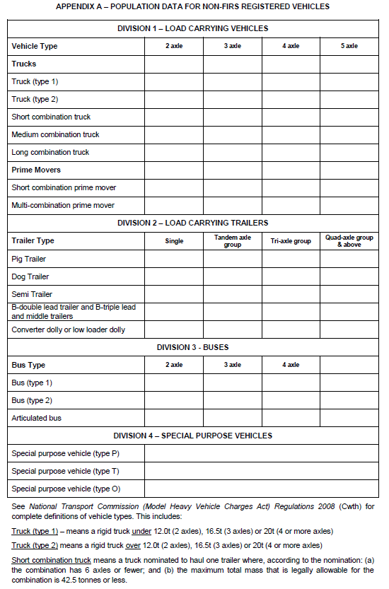

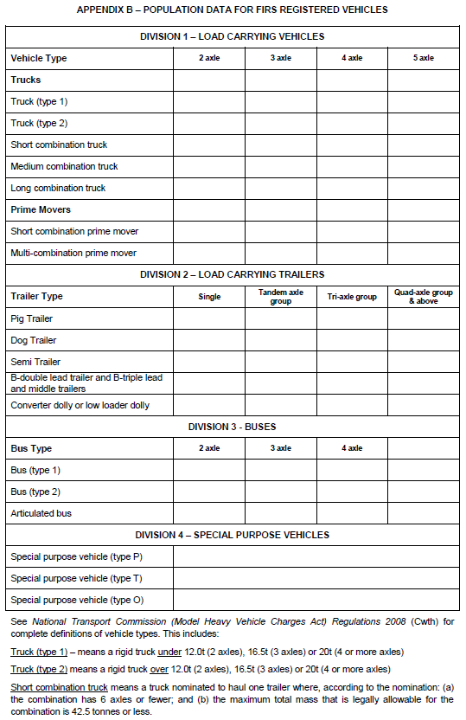

  - Appendix B – NTC Heavy Vehicle Registration Charges to commence 1 July 2012
Total heavy vehicle registration charges per unit – in dollars ($)

DIVISION 1 – LOAD CARRYING VEHICLES
Vehicle Type | 2 axle | 3 axle | 4 axle | 5 axle
Trucks
Truck (type 1) | 542 | 859 | 759 | 759
Truck (type 2) | 859 | 1,021 | 1,021 | 1,021
Short combination truck | 859 | 1,021 | 1,854 | 1,854
Medium combination truck | 6,783 | 6,783 | 7,326 | 7,326
Long combination truck | 9,361 | 9,361 | 9,361 | 9,361
Prime Movers
Short combination prime mover | 1,164 | 4,744 | 5,030 | 5,030
Multi-combination prime mover | 9,457 | 9,457 | 10,402 | 10,402
DIVISION 2 – LOAD CARRYING TRAILERS
Trailer Type | Single | Tandem group | Tri-axle group | Quad group
Pig Trailer | 550 | 1,100 | 1,650 | 2,200
Dog Trailer | 550 | 1,100 | 1,650 | 2,200
Semi Trailer | 550 | 1,100 | 1,650 | 2,200
B-double lead trailer and B-triple lead and middle trailers | 550 | 2,100 | 3,300 | 4,400
Converter dolly or low loader dolly | 550 | 1,100 | 1,650 | 2,200
DIVISION 3 - BUSES
Bus Type | 2 axle | 3 axle | 4 axle
Bus (type 1) | 488
Bus (type 2) | 488 | 2,429 | 2,429
Articulated bus |  | 488 | 488
DIVISION 4 – SPECIAL PURPOSE VEHICLES
Special purpose vehicle (type P) | No charge
Special purpose vehicle (type T) | 292
Special purpose vehicle (type O) | 365
Calculated using the formula:
365 + (365 x number of axles over 2)

  - Appendix C – Tables provided by ACT Government
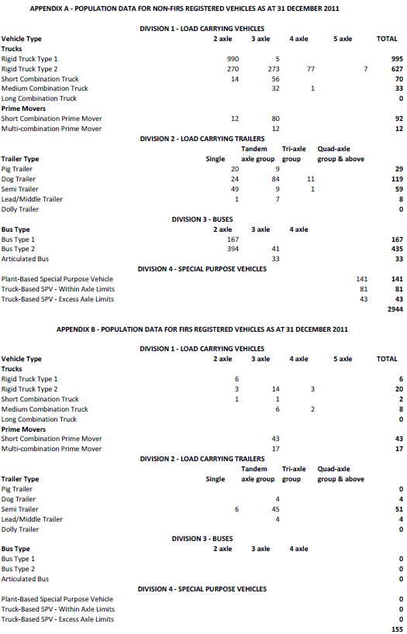

  - Appendix D – Correspondence received from NSW RMS
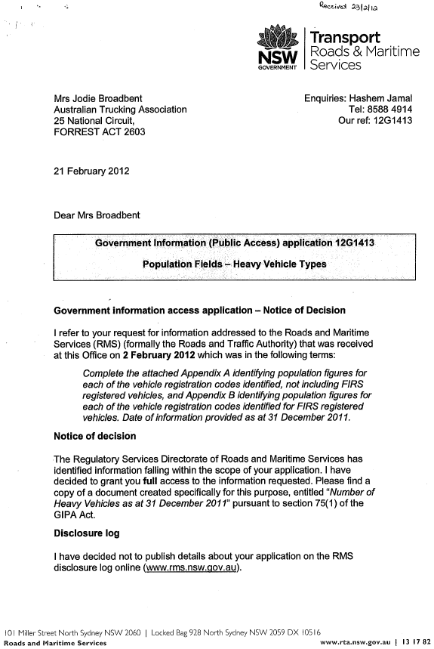
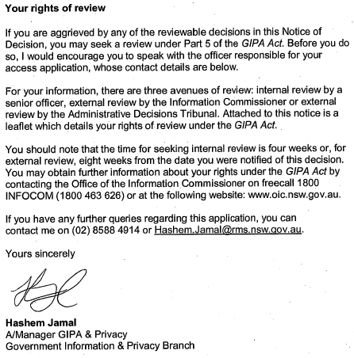

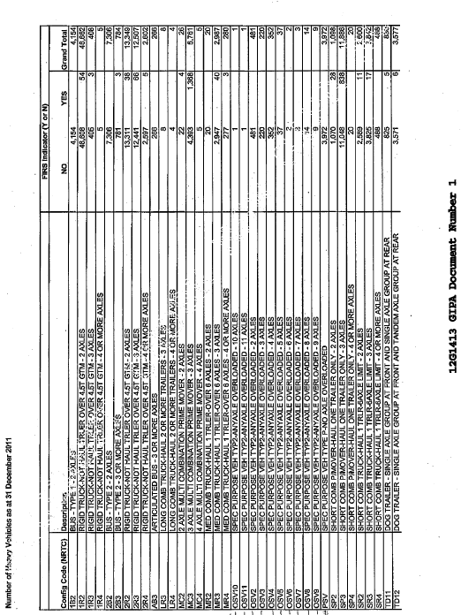
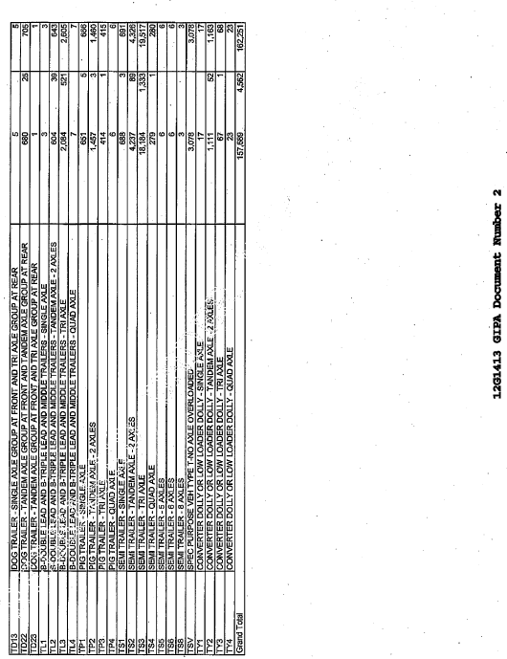

  - Appendix E – Tables provided by NT Dept Lands & Planning

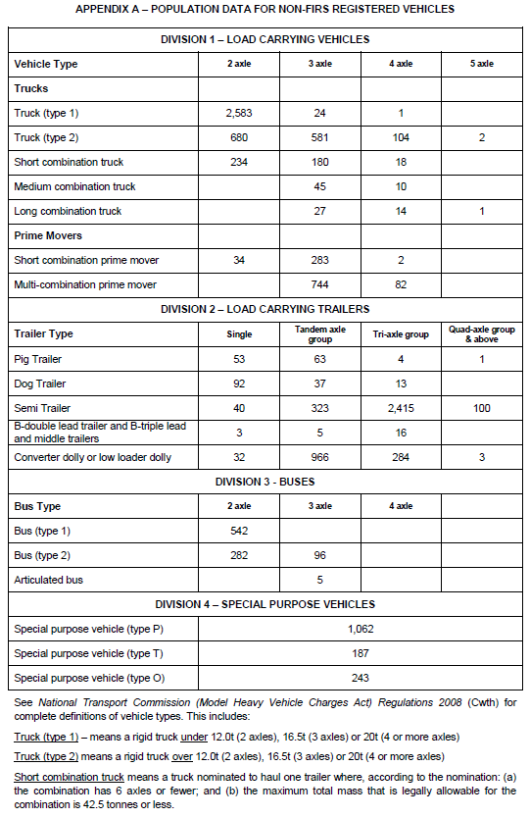

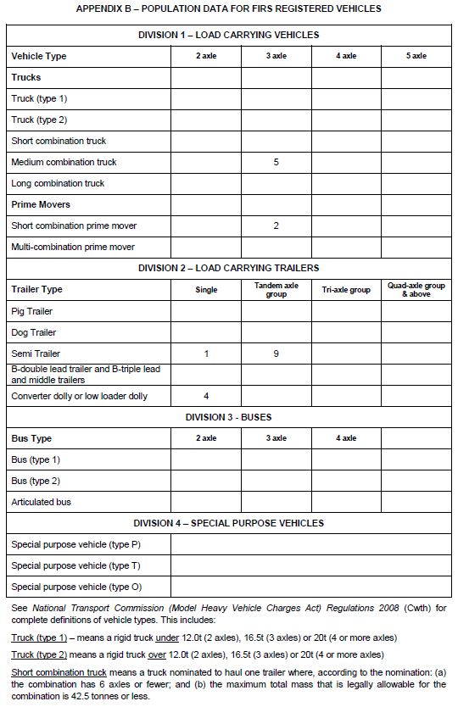

  - Appendix F – Tables provided by Qld Dept Transport and Main Roads
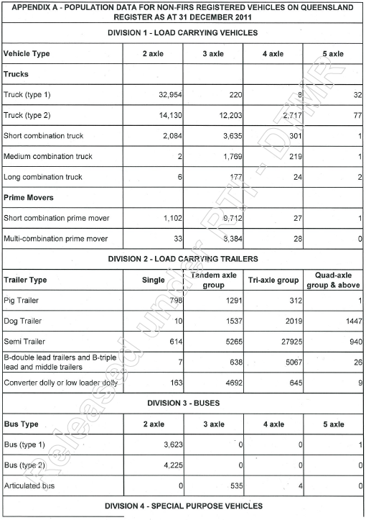
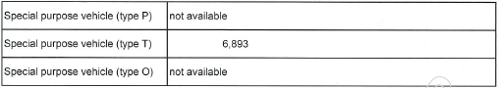

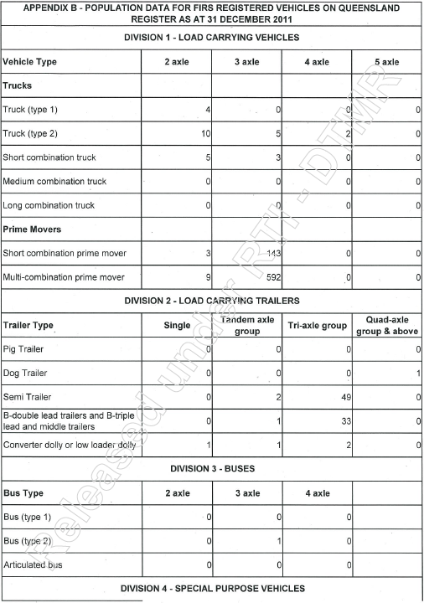
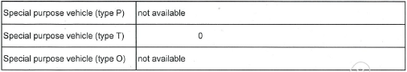

  - Appendix G – Correspondence received from SA DPTI
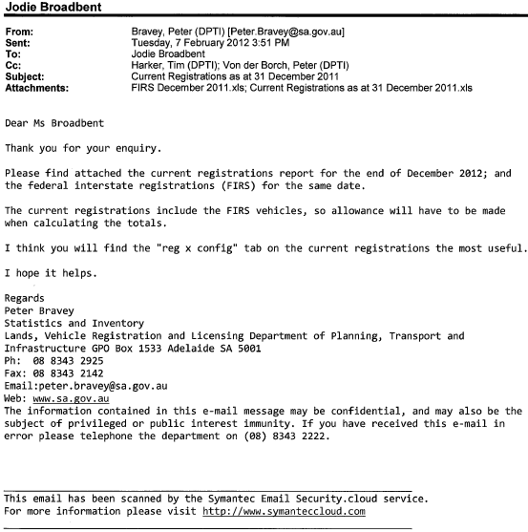

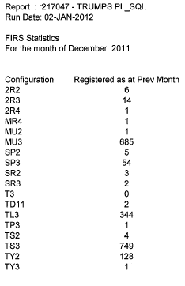
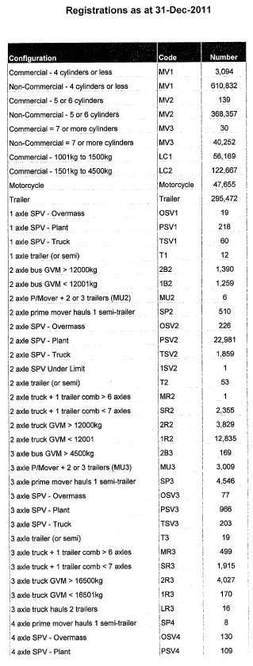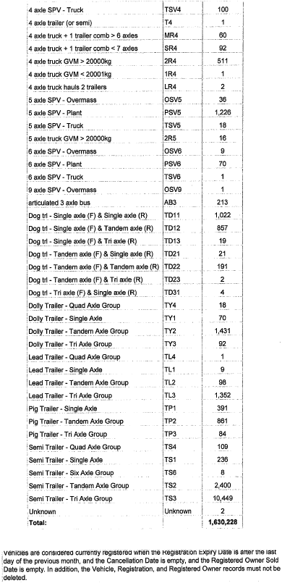

  - Appendix H – Correspondence received from TAS DIER
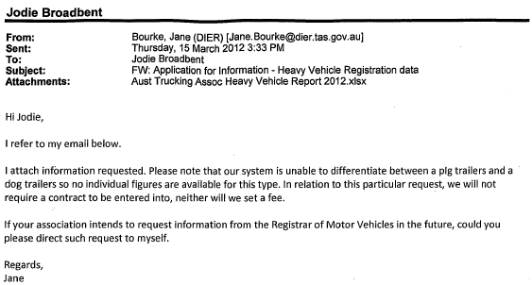
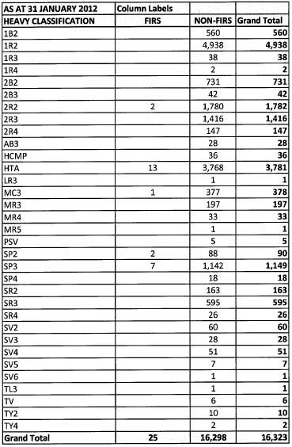

  - Appendix I – Tables provided by VicRoads
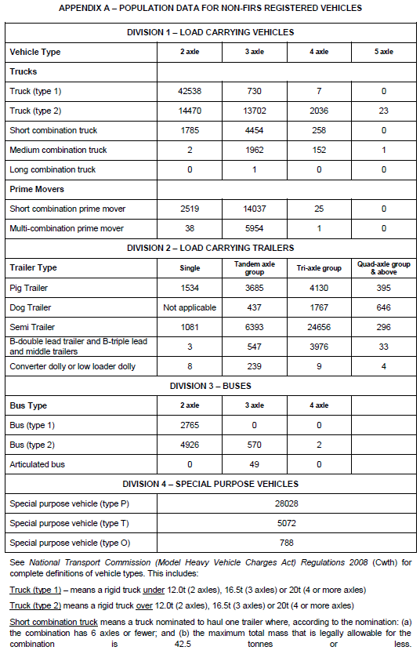

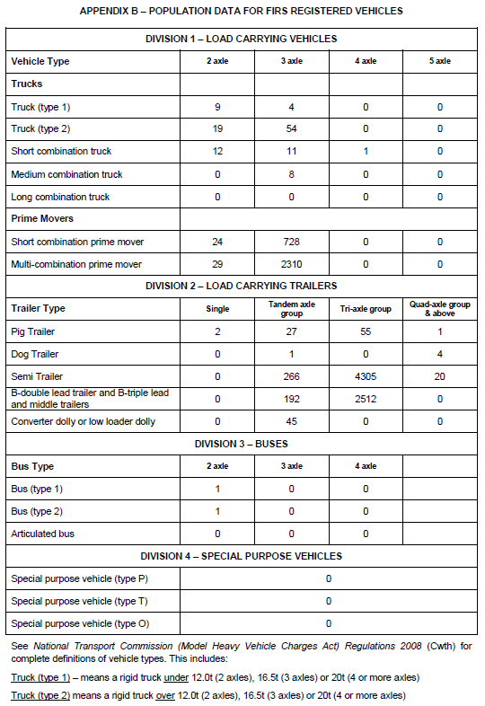

  - Appendix J – Tables provided by WA Dept of Transport
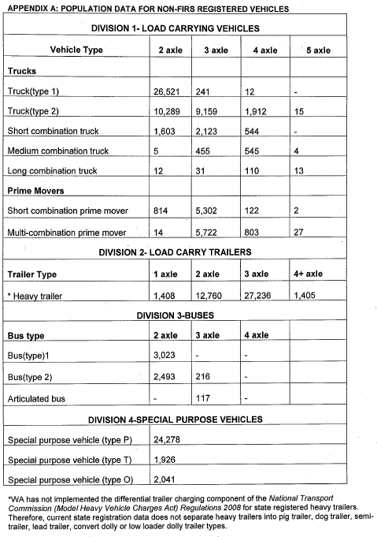

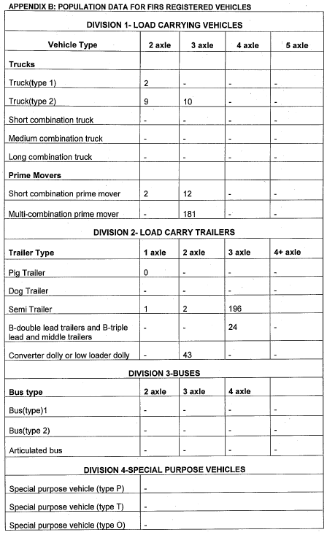

Table 15. Scenario B usage and cost allocation data (for recalculated 2012/13 charges), page 37, Heavy vehicle charges - Report to the Standing Council of Transport and Infrastructure February 2012 http://www.ntc.gov.au/DocView.aspx?DocumentId=2285
Definition of “special purpose vehicle”, page 22, Schedule 2 – Dictionary, National Transport Commission (Model Heavy Vehicle Charges Act) Regulations 2008
Table 15. Scenario B usage and cost allocation data (for recalculated 2012/13 charges), page 37, Heavy vehicle charges - Report to the Standing Council of Transport and Infrastructure February 2012 http://www.ntc.gov.au/DocView.aspx?DocumentId=2285

